

**YAVATAN: DIGITAL CHRISTIAN MISSION STRATEGIES SYSTEM**

A System Documentation Created as a

Partial Fulfillment of the Requirements

for the Degree of

Bachelor of Science

in Information Technology

By

Balatbat, Cristian O.

SRG 7TH GENERATION

**DECEMBER 2018**

**Preface**

This system documentation is created to serve its purpose in terms of documenting and recording the project plan, the project progress, the system application overview, and the project outcome. Also, this documentation is based on the agile scrum software development method, meaning, the project plan and progress is tracked through product and sprint backlogs.

The Yavatan DCMS System project team has given and pushed their efforts in developing the system and producing this documentation. Any comments and suggestions in reading this documentation are always welcome.

**Table of Contents**

|  |  |
| --- | --- |
| **Title Page**  **Preface**  **Table of Contents**  **List of Figures**  **List of Tables**   1. **Project Background**    1. Project Overview       1. Vision and Objectives       2. Project Estimation          1. Size          2. Complexity       3. Scope and Limitation       4. Project Organization       5. Project Resources          1. Human and Financial          2. Communication and Technology       6. Development Priorities       7. Success Criteria       8. Project Road Map    2. Project Plan 2. **Product Backlog**   2.1 Product Backlog for User Stories  2.2 Product Backlog for Information Security  2.3 Product Backlog for Standards  2.3.1 For User Interface and Messages  2.3.2 For Database  2.4 Product Backlog for Integration  2.5 Product Backlog for Analytics   1. **Sprint Backlog**   3.1 Sprint Backlog Table  3.1.1 User Stories  3.1.2 Information Security  3.1.3 Standards  3.1.4 Integration  3.1.5 Analytics  3.2 Sprint Backlog Burndown Charts  3.2.1 User Stories  3.2.2 Information Security  3.2.3 Standards  3.2.4 Integration  3.2.5 Analytics   1. **System Application Overview**   4.1 General Overview  4.1.1 General Description  4.1.2 User Access and Control  4.2 System Architecture  4.3 System Operations Manual  4.3.1 Getting Started  4.3.2 System Menu and Page Description   1. **Project Outcome**   5.1 Conclusion  5.2 Recommendation  **Appendices**   1. Database Dictionary 2. Test Scripts 3. Requirements Traceability Matrix 4. System Screenshots 5. Attachments | **i**  **ii**  **iii**  **v**  **vii**  1  1  3  3  3  3  4  5  5  5  5  7  7  8  11  16  18  18  19  20  22  25  25  35  38  43  45  50  50  51  52  53  54  55  55  55  56  58  58  60  77  78  --  --  --  --  -- |
|  |  |
|  |  |
|  |  |

**List of Figures**

|  |  |  |
| --- | --- | --- |
| **Figure #**  **1**  **2**  **3**  **4**  **5**  **6**  **7**  **8**  **9**  **10**  **11**  **12**  **13**  **14**  **15**  **16**  **17**  **18**  **19**  **20**  **21**  **22**  **23**  **24**  **25**  **26**  **27**  **28**  **29**  **30**  **31**  **32**  **33**  **34**  **35**  **36**  **37**  **38**  **39**  **40**  **41**  **42**  **43** | **Figure Name**  **Project Roadmap Progress Preface**  **Sprint 1 Burndown Chart for User Stories**  **Sprint 2 Burndown Chart for User Stories**  **Sprint 1 Burndown Chart for Information Security**  **Sprint 2 Burndown Chart for Information Security**  **Sprint 1 Burndown Chart for UI Design**  **Sprint 1 Burndown Chart for Database**  **Sprint 1 Burndown Chart for Integration**  **Sprint 2 Burndown Chart for Integration**  **Sprint 1 Burndown Chart for Analytics**  **Sprint 2 Burndown Chart for Analytics**  **Top-Level System Architecture of the Yavatan DCMS**  **Homepage**  **Login Page**  **Registration Page**  **Homepage**  **Login Page**  **Registration Page**  **Welcome Page**  **Homepage (Volunteer’s Page)**  **Event Details (Volunteer’s Page)**  **Group Details (Volunteer’s Page)**  **All Incoming Events (Volunteer’s Page)**  **All Groups (Volunteer’s Page)**  **Events Management (Group-Leader’s Page)**  **Event Activities Management (Group-Leader’s Page)**  **View Event Activities (Group-Leader’s Page)**  **Logistics Management (Group-Leader’s Page)**  **Attendance Management (Group-Leader’s Page)**  **View Attendance (Group-Leader’s Page)**  **Group Information Management (Group-Leader’s Page)**  **Group-Member Management (Group-Leader’s Page)**  **Materials Management (Group-Leader’s Page)**  **User Role Management (Admin’s Page)**  **Account Management (Admin’s Page)**  **Group/Organization Management (Admin’s Page)**  **Group Leader Management (Admin’s Page)**  **Regions Management (Admin’s Page)**  **City Management (Admin’s Page)**  **Religion Management (Admin’s Page)**  **Church Management (Admin’s Page)**  **Event Type Management (Admin’s Page)**  **Event Audience Management (Admin’s Page)** | **Page #**  **7**  **50**  **50**  **51**  **51**  **52**  **52**  **53**  **53**  **54**  **54**  **56**  **58**  **59**  **59**  **63**  **63**  **64**  **64**  **65**  **65**  **66**  **66**  **67**  **67**  **68**  **68**  **69**  **69**  **70**  **70**  **71**  **71**  **72**  **72**  **73**  **73**  **74**  **74**  **75**  **75**  **76**  **76** |

**List of Tables**

|  |  |  |
| --- | --- | --- |
| **Table #**  **1**  **2**  **3**  **4**  **5**  **6**  **7**  **8**  **9**  **10**  **11**  **12**  **13**  **14**  **15**  **16**  **17**  **18** | **Table Name**  **Project Organization**  **Yavatan Project Plan**  **Product Backlog for User Stories**  **Product Backlog for Information Security**  **Product Backlog for User Interface and Messages**  **Product Backlog for Database**  **Product Backlog for System Integration**  **Product Backlog for Analytics**  **Sprint Backlog for User Stories**  **Sprint Backlog for Information Security**  **Sprint Backlog for User Interface and Messages**  **Sprint Backlog for Database**  **Sprint Backlog for System Integration**  **Sprint Backlog for Analytics**  **User Access Rights**  **Administrator Menu and Its Description**  **Group-Leader Menu and Its Description**  **Volunteer Menu and Its Description** | **Page #**  **4**  **8**  **11**  **16**  **18**  **19**  **20**  **22**  **25**  **35**  **38**  **40**  **43**  **45**  **55**  **60**  **61**  **62** |

1. **Project Background**
   1. **Project Overview**

Yavatan: Digital Christian Mission Strategies System (Yavatan DCMS System) is an events management application that will greatly benefit the people, particularly to those youth and religious groups in creating and managing events, and to their respective volunteers in accessing the details and joining the events created by a particular group.

Events management is more complicated than we thought – it contains all the entities that will satisfy the event information management; the event details itself, the attendees, the factors that will affect the event, and the logistics. Also, the group and volunteers’ management may be difficult because of the manual and improper data management, thus, the collected data may not be consistent and accurate.

Yavatan basically provides ease of management of events and youth groups, through web application. The users of the system will be categorized into to, the group-leader, the one who manages the events and its group, while the volunteer, is the one that registers and access the events and can join groups through the web application.

* + 1. **Vision and Objectives**

The Yavatan Development team envisions to develop a system that can help the youth groups and volunteers to ease their management and access to events and group through the development of web application, the management events and groups will be done in less effort, giving them fast and reliable web services.

The objective of the project will be discussed in core functionality categorization. The following objectives are based on the project team’s understanding of the business process, therefore, using it as a basis for creating a technical view of the objectives of the system.

1. Registration

To create a system that will allow the volunteers to create their own account to the system, together with their personal information to be included, and will allow them to register for an event.

2. Event Management

To create a system that will allow the group leaders to create and manage their own events.

3. Group Management

To create a system that will allow the group leaders to manage the identity of the group and the details, application, and status of their volunteers.

4. Attendance Management

To create a system that will allow the group leaders and volunteers to add and monitor event’s attendance.

5. User Account Management

To create a system that will allow the system administrator to create the group leader’s user account and manage the status of all user accounts.

6. Data Mining

To create a system that will allow the system administrator to mine data from a source, particular the city and religion per regions data.

7. Predictive Analysis

To create a system that will allow the group leader to create events based on the prescription acquired from the analysis.

* + 1. **Project Estimation**
       1. **Size**

The team estimated 1 month to finish the whole system.

* + - 1. **Complexity**

The development team estimated the complexity of project ranging between medium to highly complexity.

* + 1. **Scope and Limitation**

The following scope and limitation of the system will be discussed in core functionality categorization.

1. Registration

The system only caters the registration of the volunteers, by creating an account and joining events.

2. Event Management

The group leader of a certain group cannot access and manage the other events created by other group leaders; There is no interaction between group leaders in the system.

3. Group Management

The group leader has the capability to change the details of the group set by the system administrator; The group leader can appraise and toggle the status of his/her group members.

4. Attendance Management

The group leader who created the event and the volunteer who joined the event are the ones that can only add and monitor event’s attendance.

5. User Account Management

The system administrator is the one that only access the accounts created in the system and the only one who is allowed to change some details and toggle the status of a particular account.; the group leader and the volunteer user accounts can only change their password.

6. Data Mining

The system administrator is the only person who’s allowed to mine data. An internet connection is required.

7. Predictive Analysis

The system accumulated its prescription based on the given datasets from the database, together with the programmed algorithm and conditional statements.

* + 1. **Project Organization**

**Table 1**

Project Organization

|  |  |
| --- | --- |
| Person-In-Charged | ROLE |
| Sarah Joy M. Lambino | Product Owner; Project Initiator;  Business Analyst; Stakeholder;  Document Analyst |
| Rosicar E. Escober | Project Adviser; Project Sponsor |
| Cristian O. Balatbat | Lead Programmer;  Document Analyst |

* + 1. **Project Resources**
       1. **Human and Financial**

***Ms. Sarah Joy M. Lambino***, as the project initiator and product owner, provides enough morale and financial support in developing the system;

***Prof. Rosicar E. Escober***, as the project sponsor and adviser, provides advises and financial assistance in developing the system;

***Mr. Cristian O. Balatbat***, as the Lead Programmer and Document Analyst, for developing the system and creating its documentation.

* + - 1. **Communication and Technology**

Using sublime text for code text-editing; xampp as the localhost server; phpMyAdmin as the database management system; Google Chrome, Microsoft Edge and Mozilla Firefox as the browser for testing and presenting the system; using the messenger as the medium of communication between the project organization; and the Microsoft word and project in creating the documentation.

* + 1. **Development Priorities**

The priorities set on this project is divided into two term length of development, which is the short-term and the long-term.

The short-term development deliberates the feature that can be expected after a short period of time, from its starting point up to its working point, while the long-term development deliberates the finish or the whole core functionality of the module, from its working point up to its finish point.

The priorities are discussed on the following modules below:

1. Registration

Short Term: The system administrator can add the group leader’s details; The volunteers can register for an account to the system.

Long Term: The volunteers can join and unjoin an event.

2. Event Management

Short Term: Can add and modify event details;

Long Term: Marking the event done; lay-outing of budget; application of predictive analysis.

3. Group Management

Short Term: Can view and modify group details; Can view all the group members.

Long Term: The group leader can toggle the group member’s status as contact and its youth group experience.

4. Attendance Management

Short Term: The group leader created the event can add attendance.

Long Term: The volunteers that is registered in the event can add attendance.

5. User Account Management

Short Term: The system administrator can add the group leader’s account; Can also view all registered accounts.

Long Term: The system administrator can modify and disable an account.

6. Data Mining

Short Term: The system administrator can mine data in an off-line outsourced dataset.

Long Term: The system administrator can mine data in the internet.

7. Predictive Analysis

Short Term: The prescription will be accumulated from the given datasets, applying the classification and inference method for analysis and multiple conditional statements.

Long Term: Applying the prescription to events management, group management and dashboard analytics.

* + 1. **Success Criteria**

In order for the system to be called a success, the system should:

1. The system should be working providing its core functionalities, so it can provide its core application services to satisfy the users.

2. The system should be integrated into its other sub-modules to provide real and reliable transaction scenarios in terms of using the information management system, by transferring data to one another.

3. The system’s process flow must be aligned to the business process of the said organization in order to provide correct and reliable transactions.

4. The system must and should have a reliable security to in order to lessen or neglect vulnerabilities and must be compliant to the ISO 27001 and to the data privacy act of the Philippines, in terms of protecting personal information and other sensitive data.

* + 1. **Project Road Map**

The project roadmap progress scope is only limited to 2 sprints (4 weeks), from 1st week of November up to the 4th week of November. The consumed efforts are measured and plotted in days, 4 weeks = 28 days.

**Figure 1. Project Roadmap Progress**

* 1. **Project Plan**

The project plan is divided into priorities per task – the short term and long-term.

**Table 2**

Yavatan Project Plan

|  |  |  |  |  |  |
| --- | --- | --- | --- | --- | --- |
| TASK NAME | RESPONSIBLE MEMBER | START | END | DAYS | STATUS |
| **Registration** | | | | | |
| Short Term: The system administrator can add the group leader’s details; The volunteers can register for an account to the system. | Balatbat, Cristian | 11/1 | 11/7 | 7 | DONE |
| Long Term: The volunteers can join and unjoin an event. | Balatbat, Cristian | 11/1 | 11/14 | 14 | DONE |
| **Event Management** | | | | | |
| Short Term: Can add and modify event details; | Balatbat, Cristian | 11/1 | 11/10 | 10 | DONE |
| Long Term: Marking the event done; lay-outing of budget; application of predictive analysis. | Balatbat, Cristian | 11/2 | 11/26 | 24 | DONE |
| **Group Management** | | | | | |
| Short Term: Can view and modify group details; Can view all the group members. | Balatbat, Cristian | 11/3 | 11/13 | 10 | DONE |
| Long Term: The group leader can toggle the group member’s status as contact and its youth group experience. | Balatbat, Cristian | 11/3 | 11/23 | 20 | DONE |
| **Attendance Management** | | | | | |
| Short Term: The group leader created the event can add attendance. | Balatbat, Cristian | 11/2 | 11/9 | 7 | DONE |
| Long Term: The volunteers that is registered in the event can add attendance. | Balatbat, Cristian | 11/2 | 11/17 | 15 | DONE |
| **User Account Management** | | | | | |
| Short Term: The system administrator can add the group leader’s account; Can also view all registered accounts. | Balatbat, Cristian | 11/3 | 11/9 | 6 | DONE |
| Long Term: The system administrator can modify and disable an account. | Balatbat, Cristian | 11/3 | 11/20 | 17 | DONE |
| **Data Mining** | | | | | |
| Short Term: The system administrator can mine data in an off-line outsourced dataset. | Balatbat, Cristian | 11/1 | 11/10 | 10 | DONE |
| Long Term: The system administrator can mine data in the internet. | Balatbat, Cristian | 11/10 | 11/20 | 10 | DONE |
| **Predictive Analysis** | | | | | |
| Short Term: The prescription will be accumulated from the given datasets, applying the classification and inference method for analysis and multiple conditional statements. | Balatbat, Cristian | 11/1 | 11/15 | 15 | DONE |
| Long Term: Applying the prescription to events management, group management and dashboard analytics. | Balatbat, Cristian | 11/10 | 11/25 | 15 | DONE |
| **Other Tasks (General)** | | | | | |
| Documentation | Balatbat, Cristian, Lambino, Sarah Joy | 11/1 | 11/29 | 29 | DONE |
| Database Planning | Balatbat, Cristian, Lambino, Sarah Joy | 11/1 | 11/7 | 7 | DONE |
| Application of Information Security | Balatbat, Cristian | 11/5 | 11/15 | 10 | DONE |
| Module Integration | Balatbat, Cristian | 11/15 | 11/25 | 10 | DONE |
| System Dashboard Analytics | Balatbat, Cristian | 11/10 | 11/25 | 15 | DONE |

1. **Product Backlog**

**2.1 Product Backlog for User Stories**

**Table 3**

Product Backlog for User Stories

|  |  |  |  |  |
| --- | --- | --- | --- | --- |
| USER STORY NO | USER STORIES | USER STORY PRIORITY | REVISED PRIORITY | STATUS |
| 1 | As a system administrator, I want to set up and manage the entities for user roles. | 1 | - | DONE |
| 2 | As a system administrator, I want to set up and manage the entities for cities. | 1 | - | DONE |
| 3 | As a system administrator, I want to set up and manage the entities for regions. | 1 | - | DONE |
| 4 | As a system administrator, I want to set up and manage the entities for religions. | 1 | - | DONE |
| 5 | As a system administrator, I want to set up and manage the entities for event types. | 1 | - | DONE |
| 6 | As a system administrator, I want to set up and manage the entities for event audience type. | 1 | - | DONE |
| 7 | As a system administrator, I want to set up and manage the entities for churches. | 2 | - | DONE |
| 8 | As a system administrator, I want to set up and manage the entities for the organization. | 1 | - | DONE |
| 9 | As a system administrator, I want to create and manage system user accounts. | 1 | 2 | DONE |
| 10 | As a system administrator, I want to mine and view the data for cities and religions per regions. | 1 | 2 | DONE |
| 11 | As a group leader, I want to create and manage my events. | 1 | - | DONE |
| 12 | As a group leader, I want to layout the budget and expenses of my events. | 2 | - | DONE |
| 13 | As a group leader, I want to mark my event as done. | 2 | - | DONE |
| 14 | As a group leader, I want to view all the pending events I created. | 1 | - | DONE |
| 15 | As a group leader, I want to have an event entry analysis based the system prescription before saving my entries in creating an event | 2 | - | DONE |
| 16 | As a group leader, I want to modify the details of the event even after I saved it. | 1 | 2 | DONE |
| 17 | As a group leader, I want to add and view the activities for the particular event I created. | 1 | - | DONE |
| 18 | As a group leader, I want to add and view the logistics for the particular event I created. | 1 | - | DONE |
| 19 | As a group leader, I want to add and view the attendance for the particular event I created. | 1 | 2 | DONE |
| 20 | As a group leader, I want to modify the details of the group I was assigned to. | 1 | 2 | DONE |
| 21 | As a group leader, I want to view and manage the member of my group. | 1 | 2 | DONE |
| 22 | As a group leader, I want to toggle the status of my volunteers and group members | 1 | 2 | DONE |
| 23 | As a group leader, I want change the status of my member if they are a contact or not. | 1 | 2 | DONE |
| 24 | As a group leader, I want to send an announcement via short message service. | 2 | - | PENDING |
| 25 | As a group leader, I want to add, view and manage the group’s materials. | 1 | - | DONE |
| 26 | As a volunteer, I want to see the events near my location. | 1 | - | DONE |
| 27 | As a volunteer, I want to see the groups near me and related to my religion. | 1 | - | DONE |
| 28 | As a volunteer, I want to see the events I registered, highlighted in the calendar. | 1 | - | DONE |
| 29 | As a volunteer, I want to see the list of events I registered to. | 1 | - | DONE |
| 30 | As a volunteer, I want to see the list of groups I joined in. | 1 | - | DONE |
| 31 | As a volunteer, I want to see the details of the events I want to join. | 1 | - | DONE |
| 32 | As a volunteer, I want to see the details of the group I want to join. | 1 | - | DONE |
| 33 | As a volunteer, I want to see the activities of the event I want to join. | 1 | 2 | DONE |
| 34 | As a volunteer, I want to see the materials of the event I want to join. | 1 | 2 | DONE |
| 35 | As a volunteer, I want to see all the events available in the posting of the system. | 2 | - | DONE |
| 36 | As a volunteer, I want to see all the groups available for registration of membership. | 2 | - | DONE |
| 37 | As a volunteer, I can be able to add the attendance record of a particular event I joined in. | 2 | - | DONE |

**2.2 Product Backlog for Information Security**

**Table 4**

Product Backlog for Information Security

|  |  |  |  |  |
| --- | --- | --- | --- | --- |
| USER STORY  NO | USER STORIES | USER STORY PRIORITY | REVISED PRIORITY | STATUS |
| 1 | As a system administrator, I can change the details of the accounts, with permission from the user. | 1 | - | DONE |
| 2 | As a system administrator, I can change my account password. | 2 | - | DONE |
| 3 | As a group leader, I can change my account password. | 2 | - | DONE |
| 4 | As a volunteer, I can change my account password | 2 | - | DONE |
| 5 | As a product owner, I want to have a login page so that only the authorized individuals can access the system | 1 | - | DONE |
| 6 | As a product owner, I want that the usernames be unique for every user to avoid duplication of data | 1 | - | DONE |
| 7 | As a product owner, I want to restrict my users from accessing information beyond their role to avoid any disclosure of sensitive data | 1 | - | DONE |
| 8 | As a product, I want to verify that the user has an access only to the resources/page which they are authorized to use. | 1 | - | DONE |
| 9 | As a product owner, I want that the password of my users be masked to hide the actual password from intruders. | 1 | 2 | PENDING |
| 10 | As a product owner, I want to ensure that no sensitive information is exposed through error messages. | 1 | - | DONE |
| 11 | As a product owner, I want to verify inputs from the users to ensure that all information entered are valid. | 1 | 2 | DONE |
| 12 | As a product owner, I want my developers to ensure that the algorithm for encryption is not broken or risky. | 1 | 2 | PENDING |

**2.3 Product Backlog for Standards**

**2.3.1 For User Interface and Messages**

**Table 5**

Product Backlog for User Interface and Messages Standards

|  |  |  |  |  |
| --- | --- | --- | --- | --- |
| USER STORY  NO | USER STORIES | USER STORY PRIORITY | REVISED PRIORITY | STATUS |
| 1 | As a product owner, I want to see all the input controls to know if the sizes are the same. | 1 | - | DONE |
| 2 | As a product owner, I want to see have prompt and confirmation messages before proceeding to the process. | 1 | - | DONE |
| 3 | As a product owner, I want to see a well-defined color combination of the template that is appropriate to the eyes of the users. | 1 | - | DONE |
| 4 | As a product owner, I want to see the important data that may, and will be used in the system. | 1 | - | DONE |
| 5 | As a product owner, I want to see user-interface to be flexible and compatible to different browsers | 1 | - | DONE |

**2.3.2 For Database**

**Table 6**

Product Backlog for Database

|  |  |  |  |  |
| --- | --- | --- | --- | --- |
| USER STORY  NO | USER STORIES | USER STORY PRIORITY | REVISED PRIORITY | STATUS |
| 1 | As a product owner, I want to have a centralized database of the system. | 1 | - | DONE |
| 2 | As a system administrator, I want to have a consistent naming of data tables. | 1 | - | DONE |
| 3 | As a system administrator, I want to have a consistent naming of table attributes. | 1 | - | DONE |
| 4 | As a system administrator, I want the database to have consistent key relationships. | 1 | - | DONE |
| 5 | As a system administrator, I want to have a consistent data type. | 1 | - | DONE |
| 6 | As a system administrator, I want to have a consistent data format. | 1 | - | DONE |
| 7 | As a system administrator, I want not required fields to be nullable. | 1 | - | DONE |
| 8 | As a system administrator, I want required fields not to allow null values. | 1 | - | DONE |
| 9 | As a database administrator, I want to have a database model. | 1 | - | DONE |
| 10 | As a database administrator, I want to be able to model the database. | 1 | - | DONE |

**2.4 Product Backlog for System Integration**

**Table 7**

Product Backlog for System Integration

|  |  |  |  |  |
| --- | --- | --- | --- | --- |
| USER STORY  NO | USER STORIES | USER STORY PRIORITY | REVISED PRIORITY | STATUS |
| 1 | As a system administrator, I must ensure that the changes on the entities of the setups in the system reflects to the different user account types. | 1 | - | DONE |
| 2 | As a system administrator, the data I mine must reflect to the dashboard analytics of the group leader. | 1 | 2 | DONE |
| 3 | As a group leader, I want the events I created must reflect to the volunteer’s user account module | 1 | - | DONE |
| 4 | As a group leader, the details I changed for the group must reflect to the volunteer’s user account module. | 1 | 2 | DONE |
| 5 | As a group leader, the status I change for a particular volunteer must reflect to the volunteer’s user account module. | 1 | - | DONE |
| 6 | As a group leader, the attendance I added to a particular event must match with the attendance added by the volunteer to that said event. | 1 | 2 | DONE |
| 7 | As a volunteer, I want my activities to the system to be reflected to the group leader’s account. | 1 | 2 | DONE |

**2.5 Product Backlog for Analytics**

**Table 8**

Product Backlog for Analytics

|  |  |  |  |  |
| --- | --- | --- | --- | --- |
| USER STORY  NO | USER STORIES | USER STORY PRIORITY | REVISED PRIORITY | STATUS |
| 1 | As a system administrator, I want to see the number of different status of volunteers in dashboard. | 1 | - | DONE |
| 2 | As a system administrator, I want to see the predictive analysis for the collective attendance for the previous year, current year and the prediction for it. | 2 | - | DONE |
| 3 | As a system administrator, I want to see the events per group in the dashboard. | 1 | - | DONE |
| 4 | As a system administrator, I want to see the frequency of events per group in the dashboard. | 1 | - | DONE |
| 5 | As a system administrator, I want to see the volunteers and contacts per region in the dashboard. | 1 | - | DONE |
| 6 | As a system administrator, I want to see the highest percentage of religions per region in the dashboard. | 1 | - | DONE |
| 7 | As a system administrator, I want to see the highest percentage of religions in Mindanao in the dashboard | 1 | 2 | DONE |
| 8 | As a system administrator, I want to see the language per region in the dashboard. | 1 | - | DONE |
| 9 | As a group leader, I want to see the number of different status of volunteers the in dashboard. | 1 | - | DONE |
| 10 | As a group leader, I want to see the prediction for the weather the in dashboard. | 1 | - | DONE |
| 11 | As a group leader, I want to see the prediction for the event audience attendance in the dashboard. | 1 | 2 | DONE |
| 12 | As a group leader, I want to see the prediction based on the budget evaluation in the dashboard. | 2 | - | DONE |
| 13 | As a group leader, I want to see the predictive analysis for the collective attendance for the previous year, current year and the prediction for it. | 2 | - | DONE |
| 14 | As a group leader, I want to see the events per group in the dashboard. | 2 | - | DONE |
| 15 | As a group leader, I want to see the frequency of events per group in the dashboard. | 1 | - | DONE |
| 16 | As a group leader, I want to see the volunteers and contacts per region in the dashboard. | 1 | - | DONE |
| 17 | As a group leader, I want to see the highest percentage of religions per region in the dashboard. | 1 | - | DONE |
| 18 | As a group leader, I want to see the highest percentage of religions in Mindanao in the dashboard | 1 | 2 | DONE |
| 19 | As a group leader, I want to see the language per region in the dashboard. | 1 | - | DONE` |
| 20 | As a group leader, I want to see the plotted events across the Philippine map. | 2 | - | DONE |

1. **Sprint Backlog**

**3.1 Sprint Backlog Table**

**3.1.1 User Stories**

**Table 9**

Sprint Backlog for User Stories

|  |  |  |  |  |  |  |
| --- | --- | --- | --- | --- | --- | --- |
| NO | USER  STORIES | TASKS | | REFERENCE  REQUIREMENTS | P T S | TEAM MEMBER |
| 1 | As a system administrator, I want to set up and manage the entities for user roles. | Create a table in database | |  | 30 | Cristian Balatbat |
| Design UI | |  |
| QA UI Design | |  |
| Create Functionality | |  |
| QA Functionality | |  |
| 2 | As a system administrator, I want to set up and manage the entities for cities. | Create a table in database | |  | 30 | Cristian Balatbat |
| Design UI | |  |
| QA UI Design | |  |
| Create Functionality | |  |
| QA Functionality | |  |
| 3 | As a system administrator, I want to set up and manage the entities for regions. | | Create a table in database |  | 30 | Cristian Balatbat |
| Design UI |  |
| QA UI Design |  |
| Create Functionality |  |
| QA Functionality |  |
| Design UI for homepage. |  |
| 4 | As a system administrator, I want to set up and manage the entities for religions. | | Create a table in database |  | 30 | Cristian Balatbat |
| Design UI |  |
| QA UI Design |  |
| Create Functionality |  |
| QA Functionality |  |
| 5 | As a system administrator, I want to set up and manage the entities for event types. | | Create a table in database |  | 30 | Cristian Balatbat |
| Design UI |  |
| QA UI Design |  |
| Create Functionality |  |  |
| 6 | As a system administrator, I want to set up and manage the entities for event audience type. | | Create a table in database |  | 30 | Cristian Balatbat |
| Design UI |  |
| QA UI Design |  |
| Create Functionality |  |
| QA Functionality |  |
| 7 | As a system administrator, I want to set up and manage the entities for churches. | | Create a table in database |  | 30 | Cristian Balatbat |
| Design UI |  |
| QA UI Design |  |
| Create Functionality |  |
| QA Functionality |  |
| 8 | As a system administrator, I want to set up and manage the entities for the organization. | | Create a table in database |  | 30 | Cristian Balatbat |
| Design UI |  |
| QA UI Design |  |
| Create Functionality |  |
| QA Functionality |  |
| 9 | As a system administrator, I want to create and manage system user accounts. | | Create a table in database |  | 30 | Cristian Balatbat |
| Design UI |  |
| QA UI Design |  |
| Create Functionality |  |
| QA Functionality |  |
| 10 | As a system administrator, I want to mine and view the data for cities and religions per regions. | | Create a table in database |  | 30 | Cristian Balatbat |
| Design UI |  |
| QA UI Design |  |
| Create Functionality |  |
| QA Functionality |  |
| 11 | As a group leader, I want to create and manage my events. | | Create a table in database |  | 30 | Cristian Balatbat |
| Design UI |  |
| QA UI Design |  |
| Create Functionality |  |
| QA Functionality |  |
| 12 | As a group leader, I want to layout the budget and expenses of my events. | | Create a table in database |  | 30 | Cristian Balatbat |
| Design UI |  |
| QA UI Design |  |
| Create Functionality |  |
| QA Functionality |  |
| 13 | As a group leader, I want to mark my event as done. | | Create a table in database |  | 30 | Cristian Balatbat |
| Design UI |  |
| QA UI Design |  |
| Create Functionality |  |
| QA Functionality |  |
| 14 | As a group leader, I want to view all the pending events I created. | | Create a table in database |  | 30 | Cristian Balatbat |
| Design UI |  |
| QA UI Design |  |
| Create Functionality |  |
| QA Functionality |  |
| 15 | As a group leader, I want to have an event entry analysis in prescription before saving my entries in creating an event. | | Create a table in database |  | 30 | Cristian Balatbat |
| Design UI |  |
| QA UI Design |  |
| Create Functionality |  |
| QA Functionality |  |
| 16 | As a group leader, I want to modify the details of the event even after I saved it. | | Create a table in database |  | 30 | Cristian Balatbat |
| Design UI |  |
| QA UI Design |  |
| Create Functionality |  |
| QA Functionality |  |
| 17 | As a group leader, I want to add and view the activities for the particular event I created. | | Create a table in database |  | 30 | Cristian Balatbat |
| Design UI |  |
| QA UI Design |  |
| Create Functionality |  |
| QA Functionality |  |
| QA functionality |  |
| 18 | As a group leader, I want to add and view the logistics for the particular event I created. | | Create a table in database |  | 30 | Cristian Balatbat |
| Design UI |  |
| QA UI Design |  |
| Create Functionality |  |
| QA Functionality |  |
| 19 | As a group leader, I want to add and view the attendance for the particular event I created. | | Create a table in database |  | 30 | Cristian Balatbat |
| Design UI |  |
| QA UI Design |  |
| Create Functionality |  |
| QA Functionality |  |
| 20 | As a group leader, I want to modify the details of the group I was assigned to. | | Create a table in database |  | 30 | Cristian Balatbat |
| Design UI |  |
| QA UI Design |  |
| Create Functionality |  |
| QA Functionality |  |
| 21 | As a group leader, I want to view and manage the member of my group. | | Create a table in database |  | 30 | Cristian Balatbat |
| Design UI |  |
| QA UI Design |  |
| Create Functionality |  |
| QA Functionality |  |
| 22 | As a group leader, I want to toggle the status of my volunteers and group members | | Create a table in database |  | 30 | Cristian Balatbat |
| Design UI |  |
| QA UI Design |  |
| Create Functionality |  |
| QA Functionality |  |
| 23 | As a group leader, I want change the status of my member if they are a contact or not. | | Create a table in database |  | 30 | Cristian Balatbat |
| Design UI |  |
| QA UI Design |  |
| Create Functionality |  |
| QA Functionality |  |
| 24 | As a group leader, I want to send an announcement via short message service. | | Create a table in database |  | 30 | Cristian Balatbat |
| Design UI |  |
| QA UI Design |  |
| Create Functionality |  |
| QA Functionality |  |
| 25 | As a group leader, I want to add, view and manage the group’s materials. | | Create a table in database |  | 30 | Cristian Balatbat |
| Design UI |  |
| QA UI Design |  |
| Create Functionality |  |
| QA Functionality |  |
| 26 | As a volunteer, I want to see the events near my location. | | Create a table in database |  | 30 | Cristian Balatbat |
| Design UI |  |
| QA UI Design |  |
| Create Functionality |  |
| QA Functionality |  |
| 27 | As a volunteer, I want to see the groups near me and related to my religion. | | Create a table in database |  | 30 | Cristian Balatbat |
| Design UI |  |
| QA UI Design |  |
| Create Functionality |  |
| QA Functionality |  |
| 28 | As a volunteer, I want to see the events I registered, highlighted in the calendar. | | Create a table in database |  | 30 | Cristian Balatbat |
| Design UI |  |
| QA UI Design |  |
| Create Functionality |  |
| QA Functionality |  |
| 29 | As a volunteer, I want to see the list of events I registered to. | | Create a table in database |  | 30 | Cristian Balatbat |
| Design UI |  |
| QA UI Design |  |
| Create Functionality |  |
| QA Functionality |  |
| 30 | As a volunteer, I want to see the list of groups I joined in. | | Create a table in database |  | 30 | Cristian Balatbat |
| Design UI |  |
| QA UI Design |  |
| Create Functionality |  |
| QA Functionality |  |
| 31 | As a volunteer, I want to see the details of the events I want to join. | | Create a table in database |  | 30 | Cristian Balatbat |
| Design UI |  |
| QA UI Design |  |
| Create Functionality |  |
| QA Functionality |  |
| 32 | As a volunteer, I want to see the details of the group I want to join. | | Create a table in database |  | 30 | Cristian Balatbat |
| Design UI |  |
| QA UI Design |  |
| Create Functionality |  |
| QA Functionality |  |
| 33 | As a volunteer, I want to see the activities of the event I want to join. | | Create a table in database |  | 30 | Cristian Balatbat |
| Design UI |  |
| QA UI Design |  |
| Create Functionality |  |
| QA Functionality |  |
| 34 | As a volunteer, I want to see the materials of the event I want to join. | | Create a table in database |  | 30 | Cristian Balatbat |
| Design UI |  |
| QA UI Design |  |
| Create Functionality |  |
| QA Functionality |  |
| 35 | As a volunteer, I want to see all the events available in the posting of the system. | | Create a table in database |  | 30 | Cristian Balatbat |
| Design UI |  |
| QA UI Design |  |
| Create Functionality |  |
| QA Functionality |  |
| 36 | As a volunteer, I want to see all the groups available for registration of membership. | | Create a table in database |  | 30 | Cristian Balatbat |
| Design UI |  |
| QA UI Design |  |
| Create Functionality |  |
| QA Functionality |  |
| 37 | As a volunteer, I can be able to add the attendance record of a particular event I joined in. | | Create a table in database |  | 30 | Cristian Balatbat |
| Design UI |  |
| QA UI Design |  |
| Create Functionality |  |
| QA Functionality |  |

**3.1.2 Information Security**

**Table 10**

Sprint Backlog for Information Security

|  |  |  |  |  |  |  |
| --- | --- | --- | --- | --- | --- | --- |
| NO | USER  STORIES | TASKS | | REFERENCE  REQUIREMENTS | P T S | TEAM MEMBER |
| 1 | As a system administrator, I can change the details of the accounts, with permission from the user. | Create Functionality | |  | 15 | Cristian Balatbat |
| QA Functionality | |  |
| 2 | As a system administrator, I can change my account password. | Create Functionality | |  | 15 | Cristian Balatbat |
| QA Functionality | |  |
| 3 | As a group leader, I can change my account password. | | Create Functionality |  | 15 | Cristian Balatbat |
| QA Functionality |  |
| 4 | As a volunteer, I can change my account password. | | Create Functionality |  | 15 | Cristian Balatbat |
| QA Functionality |  |
| 5 | As a product owner, I want to have a login page so that only the authorized individuals can access the system | | Create Functionality |  | 15 | Cristian Balatbat |
| QA Functionality |  |
| 6 | As a product owner, I want that the usernames be unique for every user to avoid duplication of data | | Create Functionality |  | 15 | Cristian Balatbat |
| QA Functionality |  |
| 7 | As a product owner, I want to restrict my users from accessing information beyond their role to avoid any disclosure of sensitive data | | Create Functionality |  | 15 | Cristian Balatbat |
| QA Functionality |  |
| 8 | As a product, I want to verify that the user has an access only to the resources/page which they are authorized to use. | | Create Functionality |  | 15 | Cristian Balatbat |
| QA Functionality |  |
| 9 | As a product owner, I want that the password of my users be masked to hide the actual password from intruders. | | Create Functionality |  | 15 | Cristian Balatbat |
| QA Functionality |  |
| 10 | As a product owner, I want to ensure that no sensitive information is exposed through error messages. | | Create Functionality |  | 15 | Cristian Balatbat |
| QA Functionality |  |
| 11 | As a product owner, I want to verify inputs from the users to ensure that all information entered are valid. | | Create Functionality |  | 15 | Cristian Balatbat |
| QA Functionality |  |
| 12 | As a product owner, I want my developers to ensure that the algorithm for encryption is not broken or risky. | | Create Functionality |  | 15 | Cristian Balatbat |
| QA Functionality |  |

**3.1.3 Standards**

**3.1.3.1 For User Interface and Messages**

**Table 11**

Sprint Backlog for User Interface and Messages

|  |  |  |  |  |  |  |
| --- | --- | --- | --- | --- | --- | --- |
| NO | USER  STORIES | TASKS | | REFERENCE  REQUIREMENTS | P T S | TEAM MEMBER |
| 1 | As a product owner, I want to see all the input controls to know if the sizes are the same. | Design UI | |  | 20 | Cristian Balatbat |
| QA Design | |  |
| 2 | As a product owner, I want to see have prompt and confirmation messages before proceeding to the process. | Design UI | |  | 20 | Cristian Balatbat |
| QA Design | |  |
| 3 | As a product owner, I want to see a well-defined color combination of the template that is appropriate to the eyes of the users. | | Design UI |  | 20 | Cristian Balatbat |
| QA Design |  |
| 4 | As a product owner, I want to see the important data that may, and will be used in the system. | | Design UI |  | 20 | Cristian Balatbat |
| QA Design |  |
| 5 | As a product owner, I want to see user-interface to be flexible and compatible to different browsers | | Design UI |  | 20 | Cristian Balatbat |
| QA Design |  |

**3.1.3.2 For Database**

**Table 12**

Sprint Backlog for Database

|  |  |  |  |  |  |  |
| --- | --- | --- | --- | --- | --- | --- |
| NO | USER  STORIES | TASKS | | REFERENCE  REQUIREMENTS | P T S | TEAM MEMBER |
| 1 | As a product owner, I want to have a centralized database of the system. | Create Entities | |  | 30 | Cristian Balatbat |
| Create Relationships | |  |
| Create Constraints | |  |
| QA Structure | |  |
| 2 | As a system administrator, I want to have a consistent naming of data tables. | Create Entities | |  | 30 | Cristian Balatbat |
| Create Relationships | |  |
| Create Constraints | |  |
| QA Structure | |  |
| 3 | As a system administrator, I want to have a consistent naming of table attributes. | | Create Entities |  | 30 | Cristian Balatbat |
| Create Relationships |  |
| Create Constraints |  |
| QA Structure |  |
| 4 | As a system administrator, I want the database to have consistent key relationships. | | Create Entities |  | 30 | Cristian Balatbat |
| Create Relationships |  |
| Create Constraints |  |
| QA Structure |  |
| 5 | As a system administrator, I want to have a consistent data type. | | Create Entities |  | 30 | Cristian Balatbat |
| Create Relationships |  |
| Create Constraints |  |
| QA Structure |  |  |
| 6 | As a system administrator, I want to have a consistent data format. | | Create Entities |  | 30 | Cristian Balatbat |
| Create Relationships |  |
| Create Constraints |  |
| QA Structure |  |
| 7 | As a system administrator, I want not required fields to be nullable. | | Create Entities |  |  | Cristian Balatbat |
| Create Relationships |  |
| Create Constraints |  |
| QA Structure |  |
| 8 | As a system administrator, I want required fields not to allow null values. | | Create Entities |  | 30 | Cristian Balatbat |
| Create Relationships |  |
| Create Constraints |  |
| QA Structure |  |
| 9 | As a database administrator, I want to have a database model. | | Create Entities |  | 30 | Cristian Balatbat |
| Create Relationships |  |
| Create Constraints |  |
| QA Structure |  |
| 10 | As a database administrator, I want to be able to model the database. | | Create Entities |  | 30 | Cristian Balatbat |
| Create Relationships |  |
| Create Constraints |  |
| QA Structure |  |

**3.1.4 Integration**

**Table 13**

Sprint Backlog for Integration

|  |  |  |  |  |  |  |
| --- | --- | --- | --- | --- | --- | --- |
| NO | USER  STORIES | TASKS | | REFERENCE  REQUIREMENTS | P T S | TEAM MEMBER |
| 1 | As a system administrator, I can change the details of the accounts, with permission from the user. | Design UI | |  | 40 | Cristian Balatbat |
| QA UI Design | |  |
| Create Functionality | |  |
| QA Functionality | |  |
| 2 | As a system administrator, I can change my account password. | Design UI | |  | 40 | Cristian Balatbat |
| QA UI Design | |  |
| Create Functionality | |  |
| QA Functionality | |  |
| 3 | As a group leader, I can change my account password. | | Design UI |  | 40 | Cristian Balatbat |
| QA UI Design |  |
| Create Functionality |  |
| QA Functionality |  |
| 4 | As a volunteer, I can change my account password. | | Design UI |  | 40 | Cristian Balatbat |
| QA UI Design |  |
| Create Functionality |  |
| QA Functionality |  |
| 5 | As a product owner, I want to have a login page so that only the authorized individuals can access the system | | Design UI |  | 40 | Cristian Balatbat |
| QA UI Design |  |
| Create Functionality |  |
| QA Functionality |  |
| 6 | As a product owner, I want that the usernames be unique for every user to avoid duplication of data | | Design UI |  | 40 | Cristian Balatbat |
| QA UI Design |  |
| Create Functionality |  |
| QA Functionality |  |
| 7 | As a product owner, I want to restrict my users from accessing information beyond their role to avoid any disclosure of sensitive data | | Design UI |  | 40 | Cristian Balatbat |
| QA UI Design |  |
| Create Functionality |  |
| QA Functionality |  |

**3.1.5 Analytics**

**Table 14**

Sprint Backlog for Analytics

|  |  |  |  |  |  |  |
| --- | --- | --- | --- | --- | --- | --- |
| NO | USER  STORIES | TASKS | | REFERENCE  REQUIREMENTS | P T S | TEAM MEMBER |
| 1 | As a system administrator, I want to see the number of different status of volunteers in dashboard. | Design UI | |  | 50 | Cristian Balatbat |
| QA Design | |  |
| Create Functionality | |  |
| QA Functionality | |  |
| 2 | As a system administrator, I want to see the predictive analysis for the collective attendance for the previous year, current year and the prediction for it. | Design UI | |  | 50 | Cristian Balatbat |
| QA Design | |  |
| Create Functionality | |  |
| QA Functionality | |  |
| 3 | As a system administrator, I want to see the events per group in the dashboard. | | Design UI |  | 50 | Cristian Balatbat |
| QA Design |  |
| Create Functionality |  |
| QA Functionality |  |
| 4 | As a system administrator, I want to see the frequency of events per group in the dashboard. | | Design UI |  | 50 | Cristian Balatbat |
| QA Design |  |
| Create Functionality |  |
| QA Functionality |  |
| 5 | As a system administrator, I want to see the volunteers and contacts per region in the dashboard. | | Design UI |  | 50 | Cristian Balatbat |
| QA Design |  |
| Create Functionality |  |
| QA Functionality |  |
| 6 | As a system administrator, I want to see the highest percentage of religions per region in the dashboard. | | Design UI |  | 50 | Cristian Balatbat |
| QA Design |  |
| Create Functionality |  |
| QA Functionality |  |
| 7 | As a system administrator, I want to see the highest percentage of religions in Mindanao in the dashboard | | Design UI |  | 50 | Cristian Balatbat |
| QA Design |  |
| Create Functionality |  |
| QA Functionality |  |
| 8 | As a system administrator, I want to see the language per region in the dashboard. | | Design UI |  | 50 | Cristian Balatbat |
| QA Design |  |
| Create Functionality |  |
| QA Functionality |  |
| 9 | As a group leader, I want to see the number of different status of volunteers the in dashboard. | | Design UI |  | 50 | Cristian Balatbat |
| QA Design |  |
| Create Functionality |  |
| QA Functionality |  |
| 10 | As a group leader, I want to see the prediction for the weather the in dashboard. | | Design UI |  | 50 | Cristian Balatbat |
| QA Design |  |
| Create Functionality |  |
| QA Functionality |  |
| 11 | As a group leader, I want to see the prediction for the event audience attendance in the dashboard. | | Design UI |  | 50 | Cristian Balatbat |
| QA Design |  |
| Create Functionality |  |
| QA Functionality |  |
| 12 | As a group leader, I want to see the prediction based on the budget evaluation in the dashboard. | | Design UI |  | 50 | Cristian Balatbat |
| QA Design |  |
| Create Functionality |  |
| QA Functionality |  |
| 13 | As a group leader, I want to see the predictive analysis for the collective attendance for the previous year, current year and the prediction for it. | | Design UI |  | 50 | Cristian Balatbat |
| QA Design |  |
| Create Functionality |  |
| QA Functionality |  |
| 14 | As a group leader, I want to see the events per group in the dashboard. | | Design UI |  | 50 | Cristian Balatbat |
| QA Design |  |
| Create Functionality |  |
| QA Functionality |  |
| 15 | As a group leader, I want to see the frequency of events per group in the dashboard. | | Design UI |  | 50 | Cristian Balatbat |
| QA Design |  |
| Create Functionality |  |
| QA Functionality |  |
| 16 | As a group leader, I want to see the volunteers and contacts per region in the dashboard. | | Design UI |  | 50 | Cristian Balatbat |
| QA Design |  |
| Create Functionality |  |
| QA Functionality |  |
| 17 | As a group leader, I want to see the highest percentage of religions per region in the dashboard. | | Design UI |  | 50 | Cristian Balatbat |
| QA Design |  |
| Create Functionality |  |
| QA Functionality |  |
| 18 | As a group leader, I want to see the highest percentage of religions in Mindanao in the dashboard | | Design UI |  | 50 | Cristian Balatbat |
| QA Design |  |
| Create Functionality |  |
| QA Functionality |  |
| 19 | As a group leader, I want to see the language per region in the dashboard. | | Design UI |  | 50 | Cristian Balatbat |
| QA Design |  |
| Create Functionality |  |
| QA Functionality |  |
| 20 | As a group leader, I want to see the plotted events across the Philippine map. | | Design UI |  | 50 | Cristian Balatbat |
| QA Design |  |
| Create Functionality |  |
| QA Functionality |  |

**3.2 Sprint Backlog Burndown Chart**

**3.2.1 User Stories**

**Figure 2. Sprint 1 Burndown Chart for User Stories**

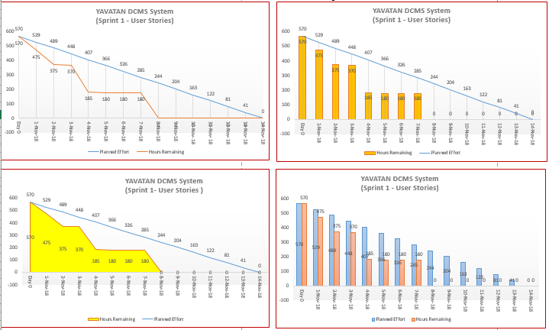

**Figure 3. Sprint 2 Burndown Chart for User Stories**

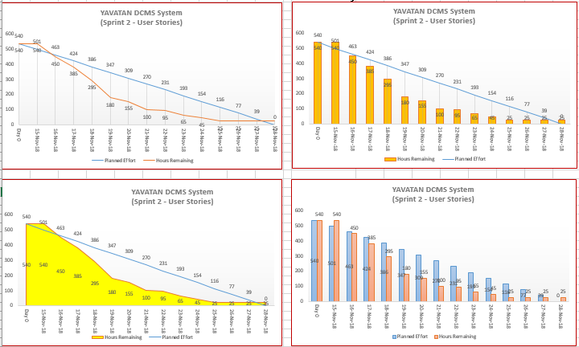

**3.2.2 Information Security**

**Figure 4. Sprint Burndown Chart for Information Security**

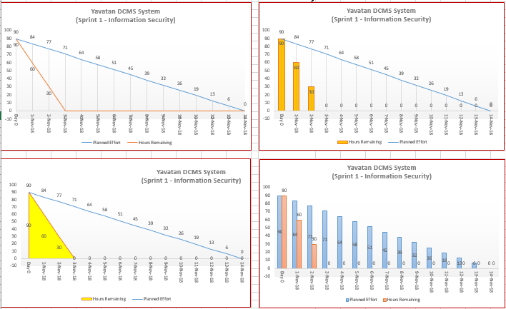

**Figure 5. Sprint Burndown Chart for Information Security**

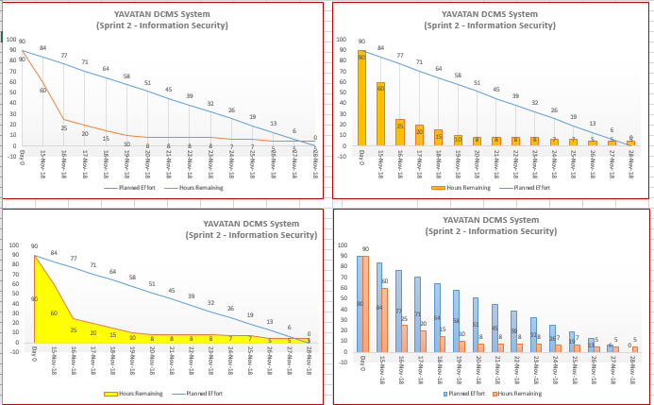

**3.2.3 Standards**

**Figure 6. Sprint 1 Burndown Chart for UI Design**

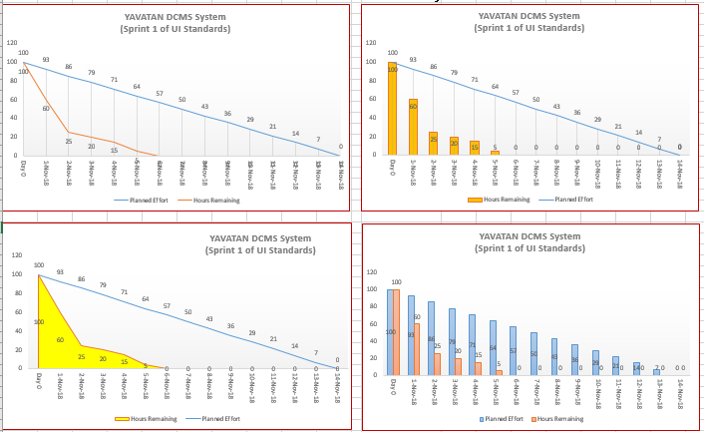

**Figure 7. Sprint 1 Burndown Chart for Database**

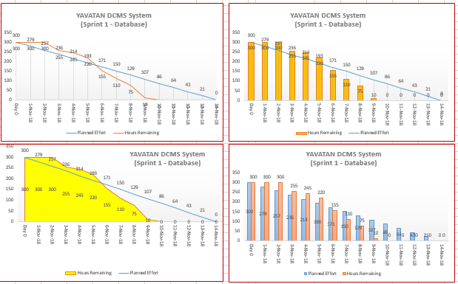

**3.2.4 Integration**

**Figure 8. Sprint 1 Burndown Chart for Integration**

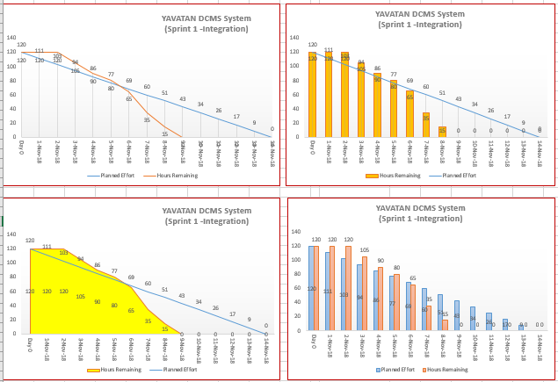

**Figure 9. Sprint 2 Burndown Chart for Integration**

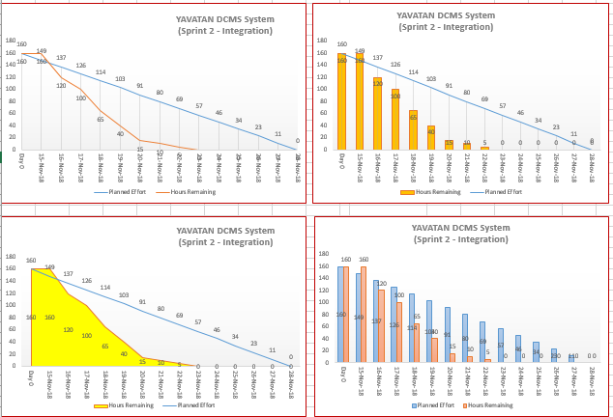

**3.2.5 Analytics**

**Figure 10. Sprint 1 Burndown Chart for Analytics**

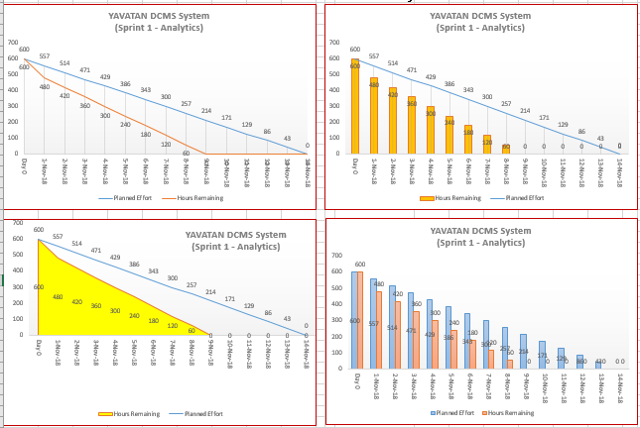

**Figure 11. Sprint 2 Burndown Chart for Analytics**

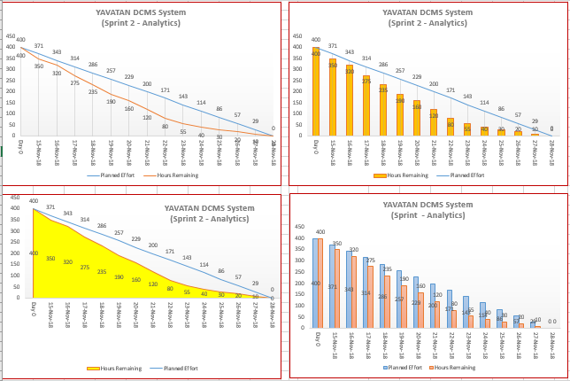

1. **System Application Overview**

**4.1 General Overview**

**4.1.1 General Description**

Yavatan System, is digital mission strategy system that manages the organization’s events and its attributes and other components – activities, logistics and its attendance. It is a web-based system, so it can run on different web browsers and if its uploaded in the web, you will be needing an internet connection in order to access the system.

The system enables the volunteer can view available and related groups and events that the user can join or register. The group leader can create events, manage group members and other group and event configurations. The administrator can add, edit, delete, view and archive data and any other related entities into the system.

**4.1.2 User Access and Control**

Yavatan has three (3) level of access that accompanies certain access rights. These are the following details:

**Table 15**

User Access Rights

|  |  |
| --- | --- |
| USER | ACCESS RIGHTS |
| Volunteer | This user access has the ability to view available and related groups and events that the user can join or register. |
| Group Leader | This user access has the ability to events, manage group members and other group and event configurations |
| System Administrator | This user access has the ability to add, edit, delete, view and archive data and any other related entities into the system. |

**4.2 System Architecture**

**Figure 12. Top-Level System Architecture of the Yavatan DCMS**

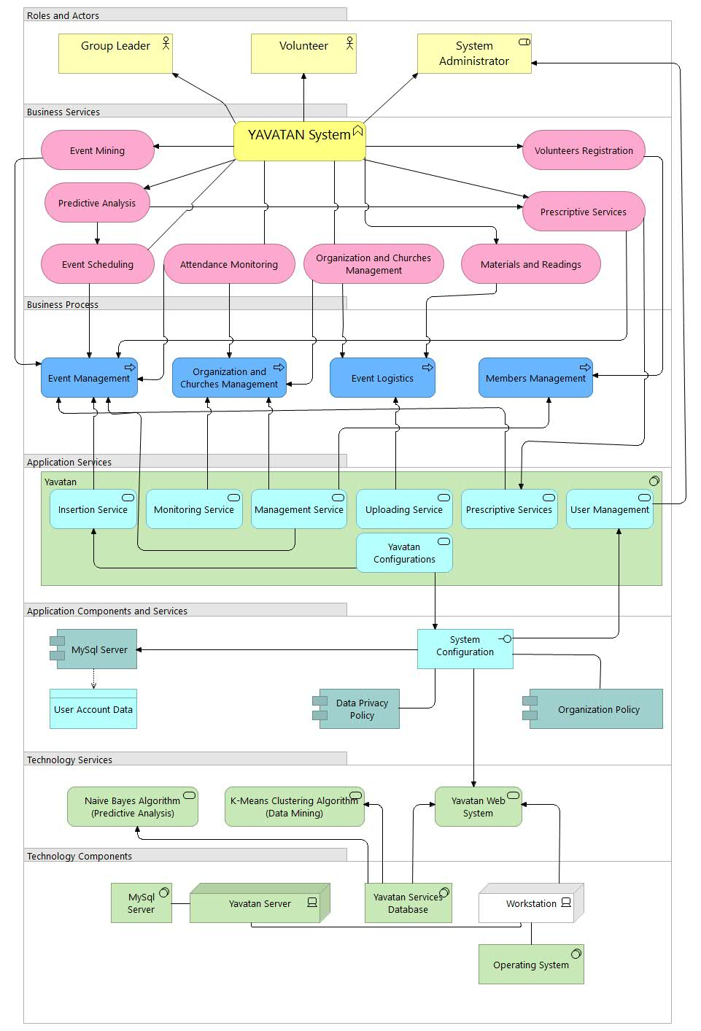

The figure shows the components of the Yavatan system – It has 7 classifications consist of the roles and actors, business services, business process, application services, application components and services, technology services and technology components. There are 3 roles and actors in the system, these are the group leaders, volunteers (members), and the system administrator. In the business services, Yavatan includes events mining, events scheduling, attendance monitoring, organization and churches management, volunteers’ registration, the predictive analysis, the prescriptive services, and the uploading of materials and readings.

The business process of Yavatan System Architecture contains 4 activities such as event management, organization and churches management, event logistics, and members management. For the Application Services, it has 7 modules named as Insertion Service, Monitoring Services, Management Services, Prescriptive Services, Uploading Services, Yavatan Configurations, and the User Management. The system used MySQL Server for storing the data of the users and creates a system configuration to update the Data Privacy Act and the organization policies of the governing bodies the will use the Yavatan system.

The system used technology services such as Clustering Algorithm for Data Mining and Classification and Inference Method for predictive analysis, specifically the Naïve Bayes algorithm that is utilized in the Web system. There are 4 technology components involved in the system, these are MySQL Server, Yavatan Server, Yavatan Services Database and the Workstation for the operating system.

**4.3 System Operations Manual**

**4.3.1 Getting Started**

This section provides a general walkthrough of the system from initiation through exit. It provides details on how to log in on the system.

### **Homepage**

The system provides a homepage or portal to show a brief information about the Yavatan system.

**Figure 13. Homepage**

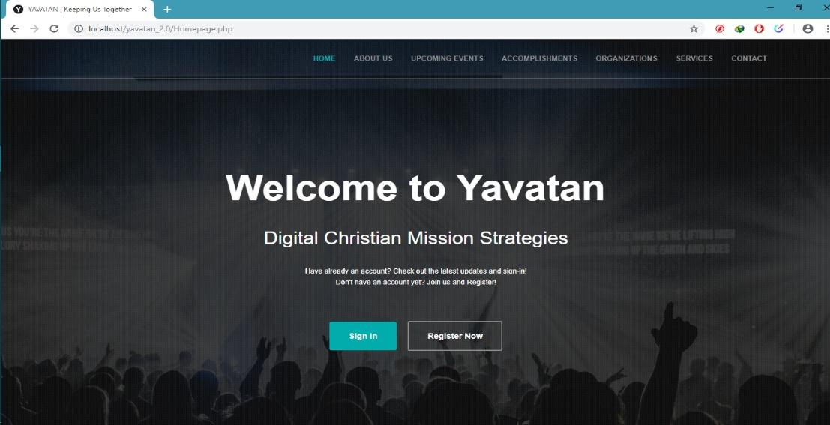

Click to redirect to the registration page

Click to redirect to the login page

## **Logging On**

The system developer will provide the default username and password to the administrator, while the volunteer user will have to register in order to have a personal account to the system, and the group leader user will be created by the administrator.

* In the Volunteer user, The Main Home Page of the system will be displayed after logging in.
* If you are a new user, go to “Register Now”. Fill up all the required information and follow the step by step process.
* In the Group Leader user, The Dashboard Page of the system will be displayed where you can see the summary or analytics of system.
* In the Administrator user, after logging in, you will be redirected to system’s dashboard.

**Figure 14. Login Page**

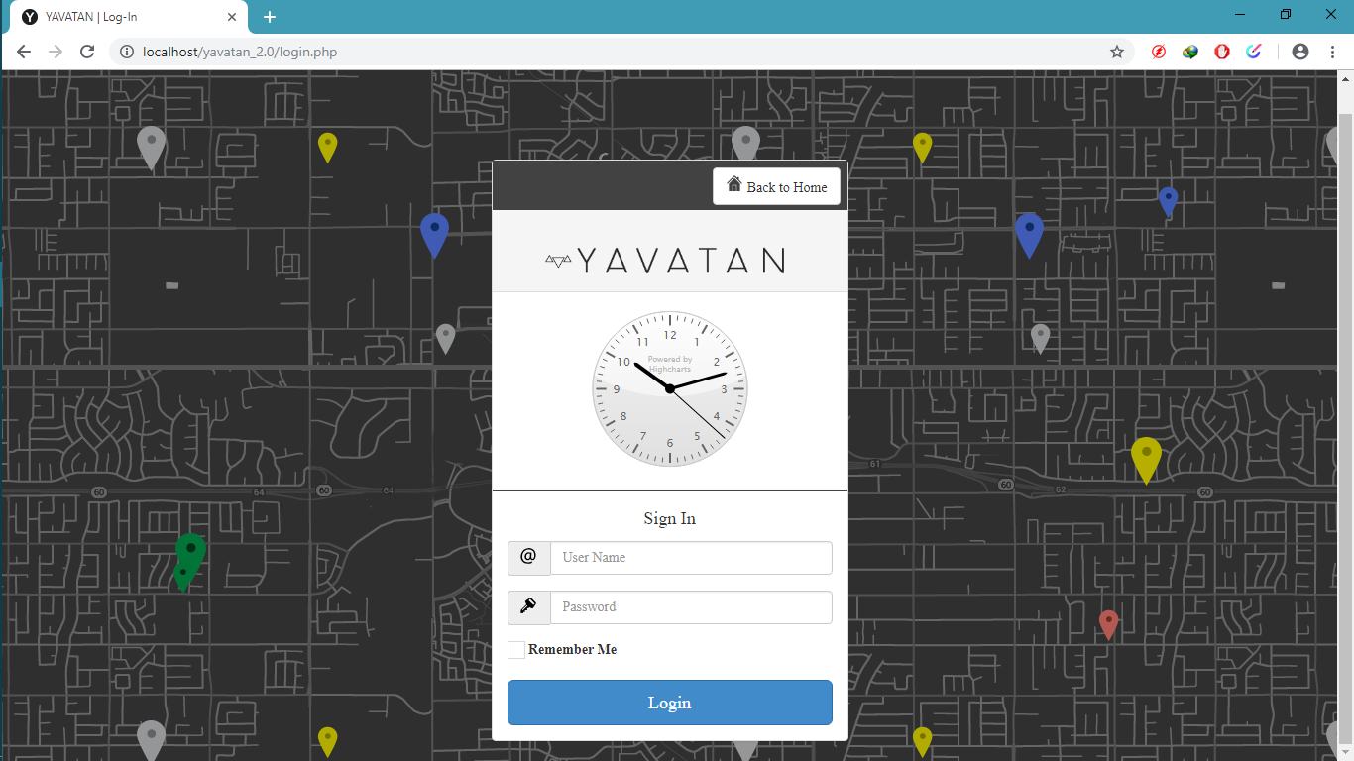

Click to proceed

Click when you want to remember your account

Fill in your password

Fill in your username

## **Registration**

Registration page is provided in order to register new users and marked as volunteer users.

**Figure 15. Registration Page**

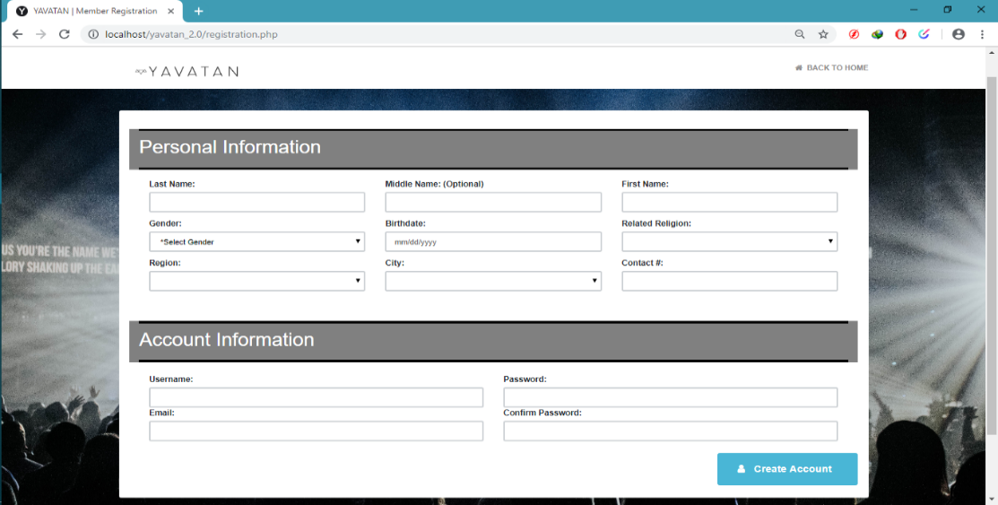

Once you fill up all the required fields just click this to register

Fill up all the required information

## **4.3.2 System Menu and Page Description**

This section describes the menus and page navigations available on the system for the volunteer user access, group leader user access and administrator access.

#### **Administrator Menu and Page Navigation**

The menus and pages available for the administrator are illustrated in the following:

**Table 16**

Administrator Menu and Its Description

|  |  |
| --- | --- |
| SCREEN PAGE | DESCRIPTION |
| **Dashboard** | Once you logged in, this page will show where you can see the analytics of the system. |
| **User Management** | A part of a system that you can manage User Roles, Account Management, Group/Organization Management, Group-Leader Management. |
| **Demographics** | This page is where you can manage regions and cities. |
| **Yavatan Configurations** | This is where the administrator manages Religion, Church, Event Type and Event Audience. |

### **Group-Leader Menu and Page Navigation**

The menus and pages available for the group-leader user are illustrated in the following:

**Table 17**

Group-Leader Menu and Its Description

|  |  |
| --- | --- |
| **SCREEN PAGE** | **DESCRIPTION** |
| **Dashboard** | This page will show where you can see the analytics for the group-leader account. |
| **Event Management** | A part of a system that you can manage events, add events, view event details, manage activities, add activities, view activity details, manage logistics and manage attendance. |
| **Group Management** | This page is where you can manage Group Information and also manages group-member. |
| **Material Setup** | Material Setup is used to add, update and archive materials. |

### **Volunteer Menu and Page Navigation**

The menus and pages available for the volunteer user are illustrated in the following:

**Table 18**

Volunteer Menu and Its Description

|  |  |
| --- | --- |
| **SCREEN PAGE** | **DESCRIPTION** |
| **Home** | This page is show when the volunteer logs in, you can see the events near you or events that near in your location, you can view suggested groups and their details. |
| **Enlisted Events** | A part of a system that you see all the events that your group created or related to your group. |
| **Joined Groups** | This page is where you can see all the group that you have joined. |
| **All Events** | Part of the volunteer page where you can see all the events regardless of the religion of the volunteer. |
| **All Groups/Orgs** | Just like the All Events, you can see here all the groups/org regardless of the religion of the volunteer. |

**Figure 16. Homepage**

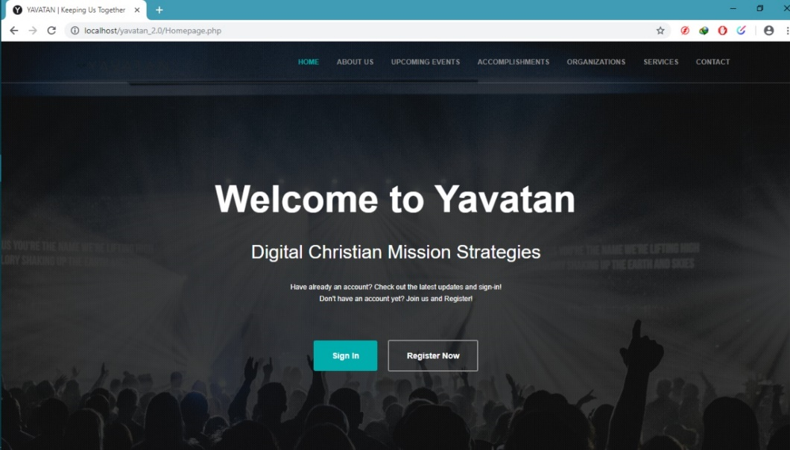

The figure above is shown before accessing the system’s Login Form.

**Figure 17. Login Page**



The figure above is used to input user’s essential information regardless of their user role to access the system.

**Figure 18. Registration Page**

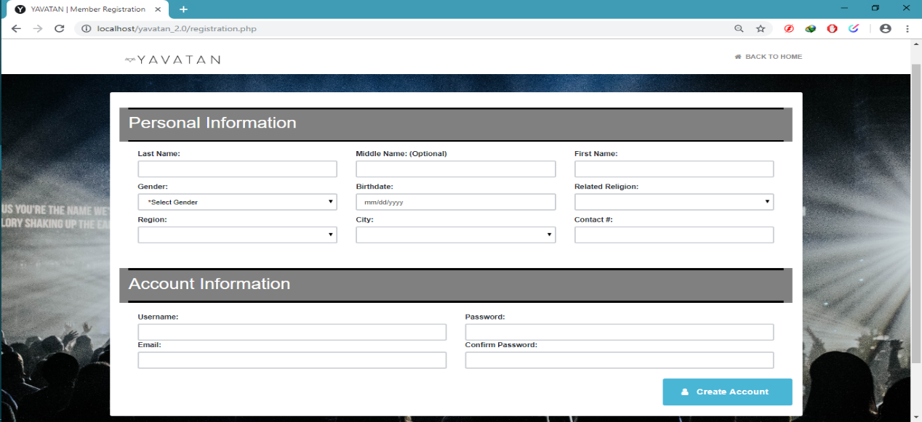

The figure above is used to register an account, once all the required field is filled the account will be created as volunteer account.

**Figure 19. Welcome Page**

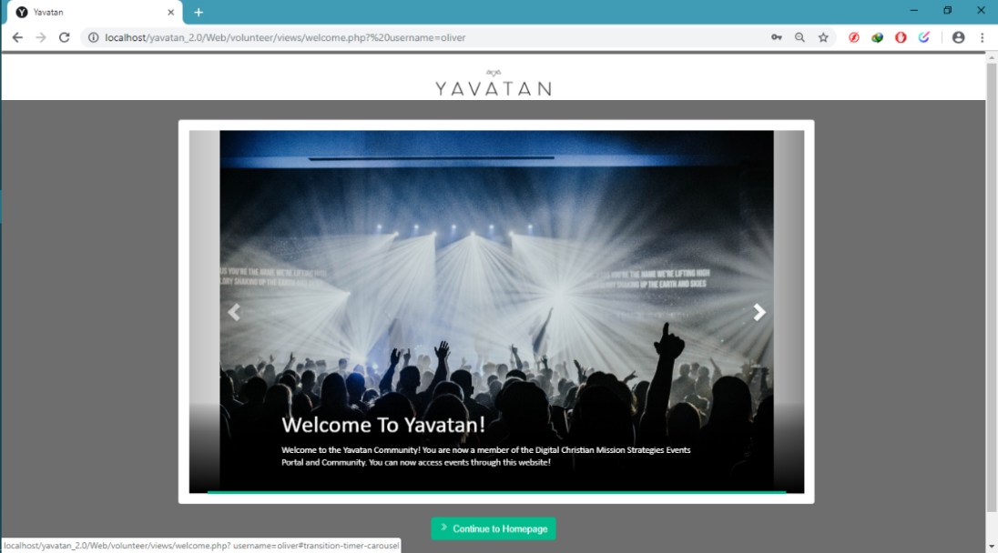

The figure above is shown after you fill-up all the required information in the registration page, you are redirected to the welcome page.

**Figure 20. Homepage (Volunteer’s Page)**

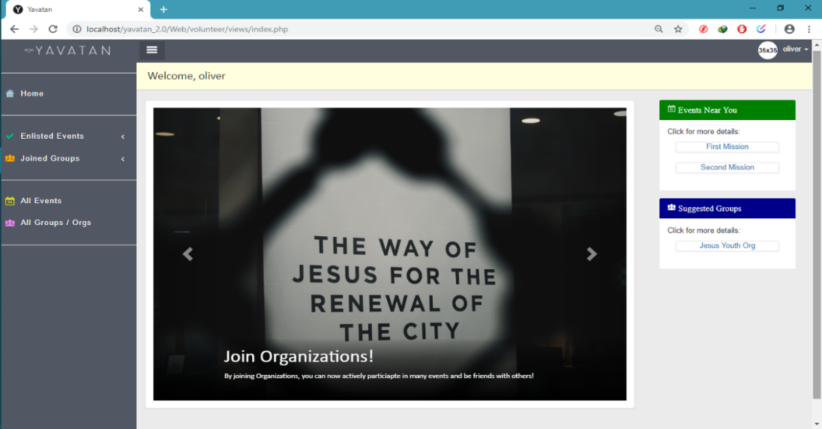

The Figure above is used where the volunteer logs in, they can see the events near them and suggested group.

**Figure 21. Event Details (Volunteer’s Page)**

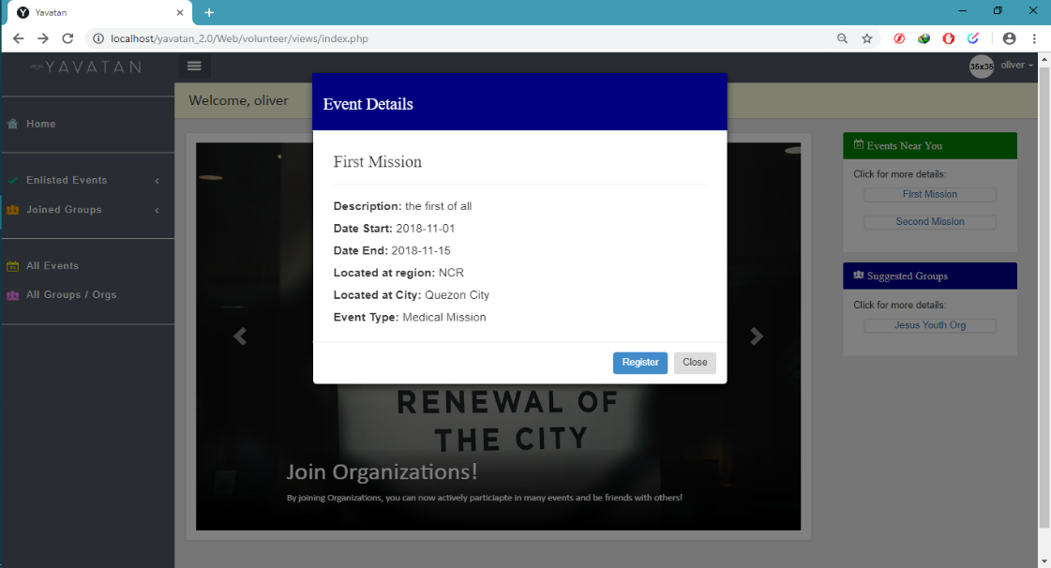

The Figure above is used to view the details of the event you clicked.

**Figure 22. Group Details (Volunteer’s Page)**

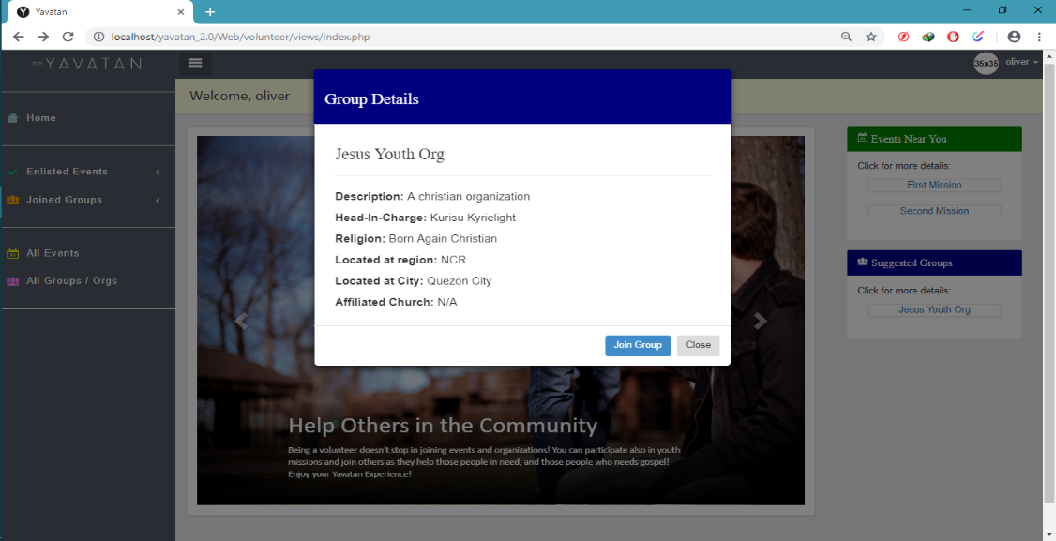

The Figure above is used to view the details of the group you want to see.

**Figure 23. All Incoming Events (Volunteer’s Page)**

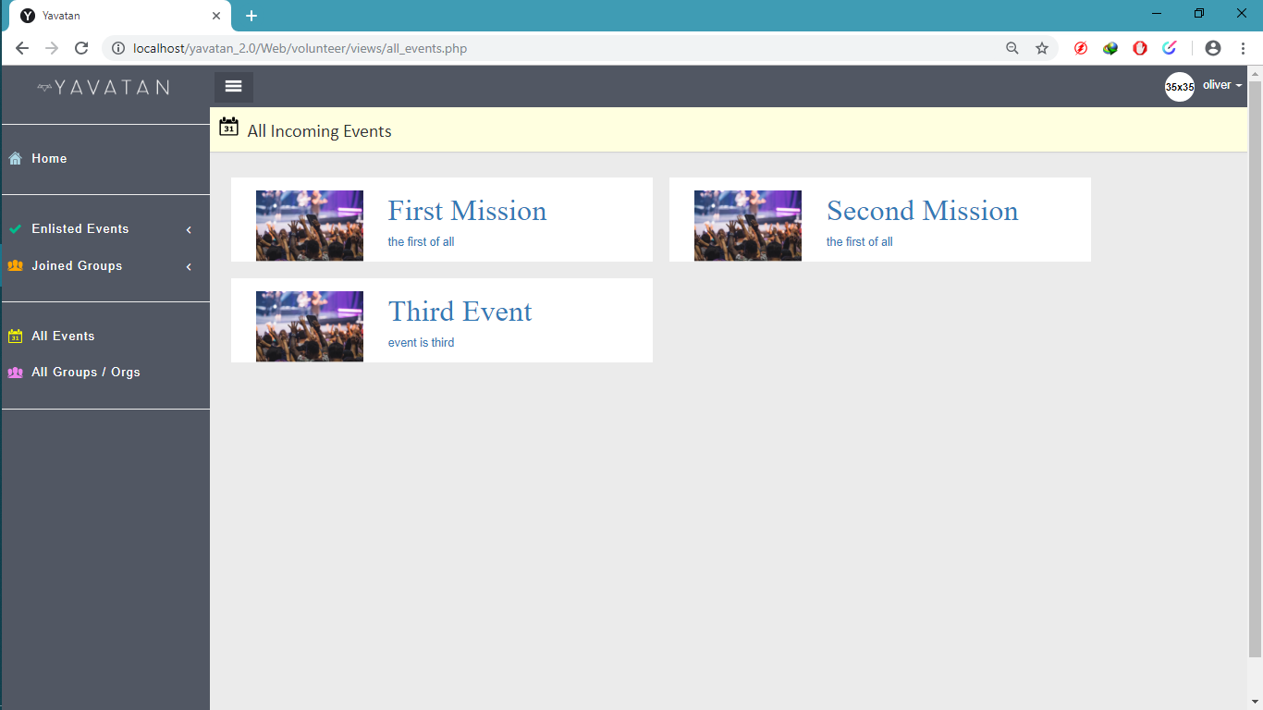

The Figure above is used where the volunteer can see all the events created by the group-leaders regardless of the volunteer’s religion.

**Figure 24. All Groups (Volunteer’s Page)**

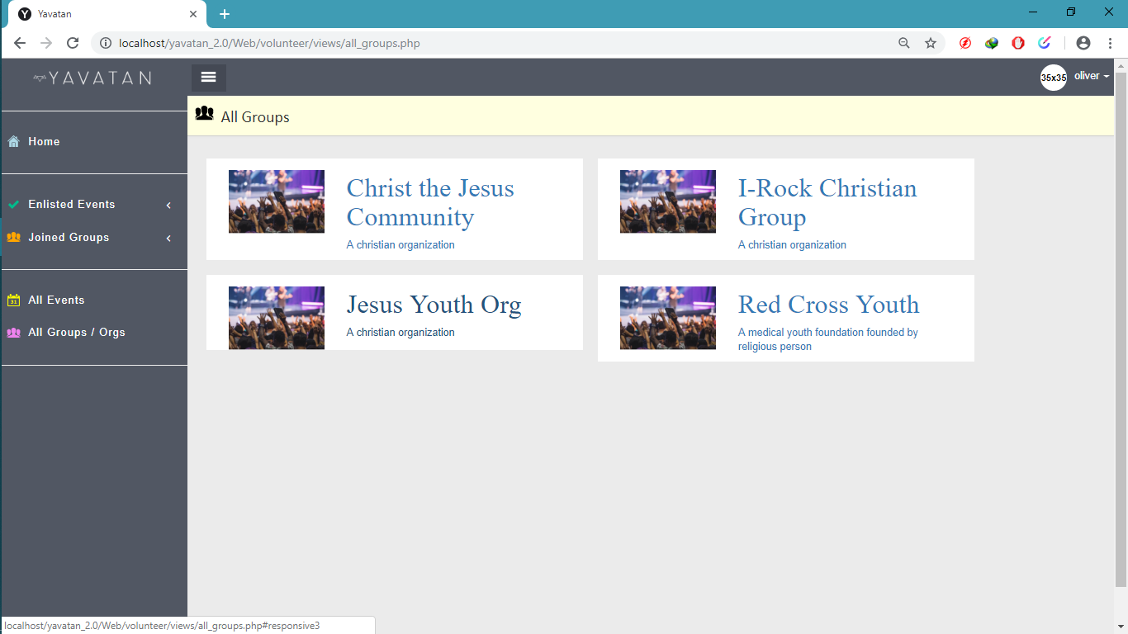

The Figure above is used where the volunteer can see all the groups existing in the system, they can see all the groups regardless of the volunteer’s religion.

**Figure 25. Events Management (Group-Leader’s Page)**

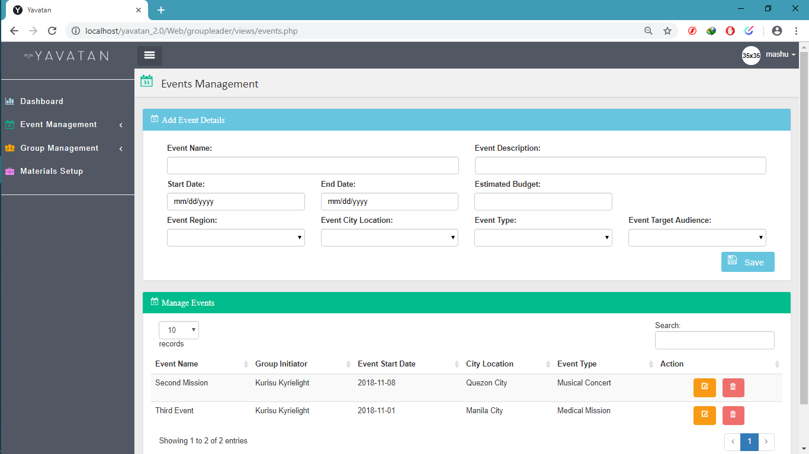

The Figure above is used to create events, update events and also archive events.

**Figure 26. Event Activities Management (Group-Leader’s Page)**

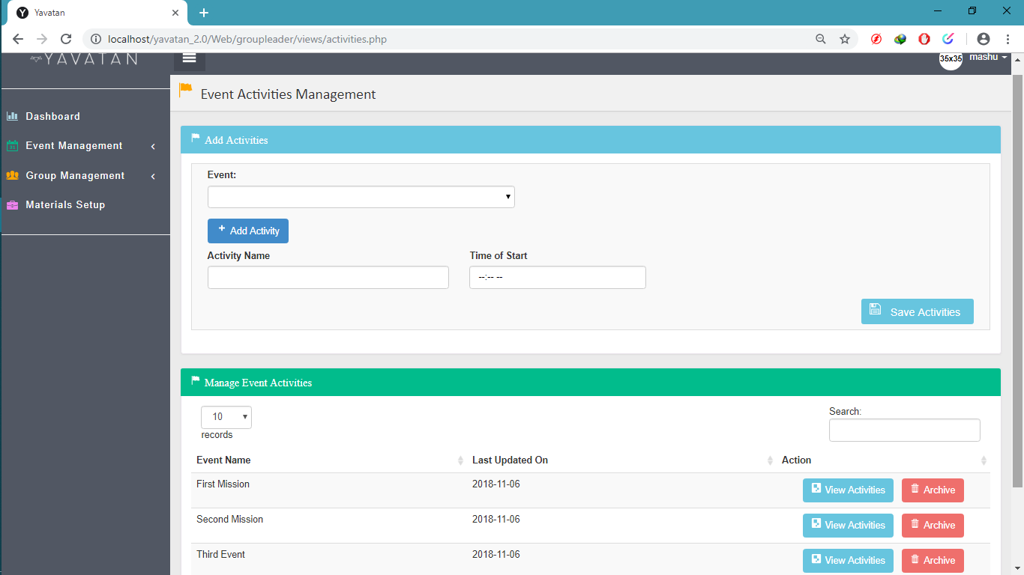

The Figure above is used to add activities in the events, also you can edit and archive activities.

**Figure 27. View Event Activities (Group-Leader’s Page)**

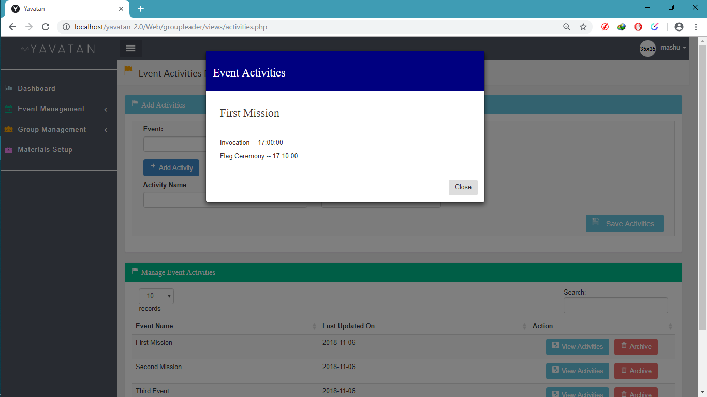

The Figure above is used when you want to view activity details in specific event.

**Figure 28. Logistics Management (Group-Leader’s Page)**

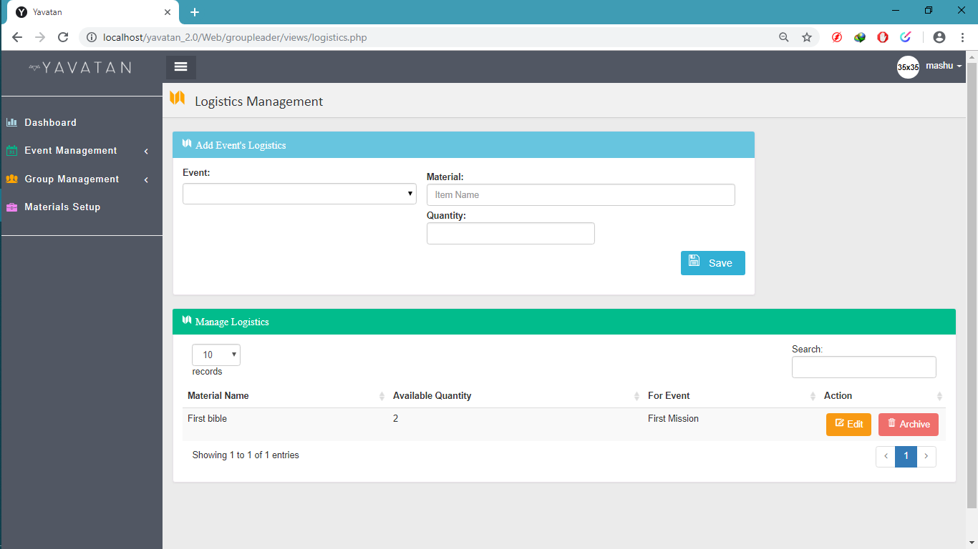

The Figure above is used to add logistics in the selected events, edit is also provides and archive.

**Figure 29. Attendance Management (Group-Leader’s Page)**

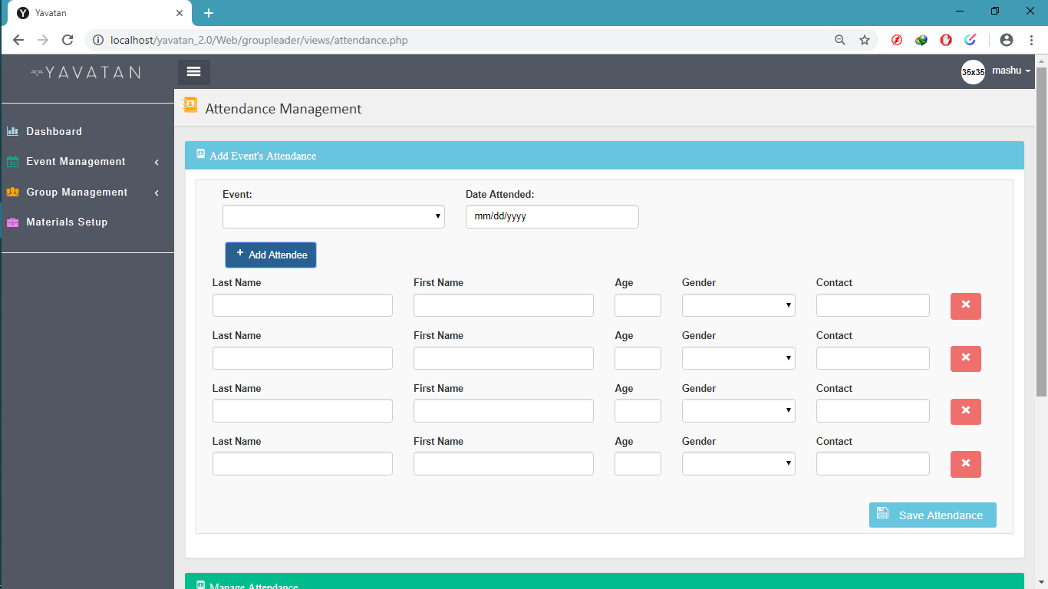

The Figure above is used to add attendee in the selected event.

**Figure 30. View Attendance (Group-Leader’s Page)**

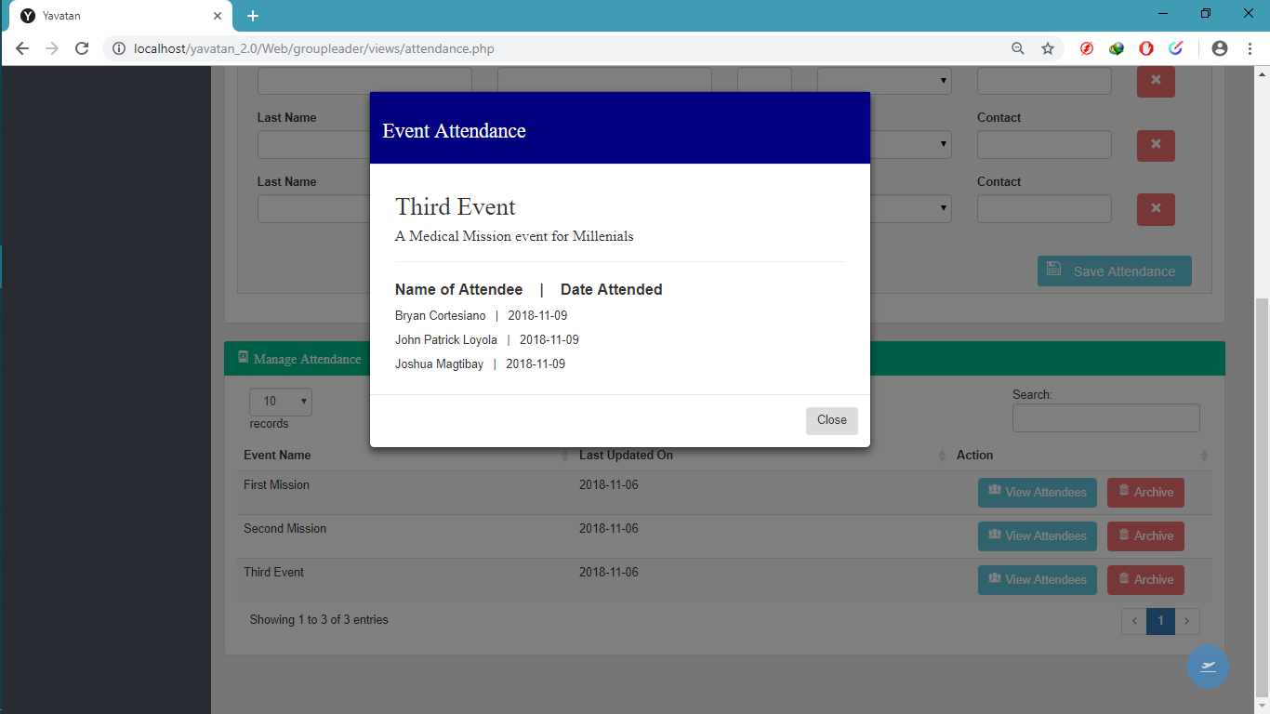

The Figure above is used to view all the attendees in the selected events you want to see.

**Figure 31. Group Information Management (Group-Leader’s Page)**

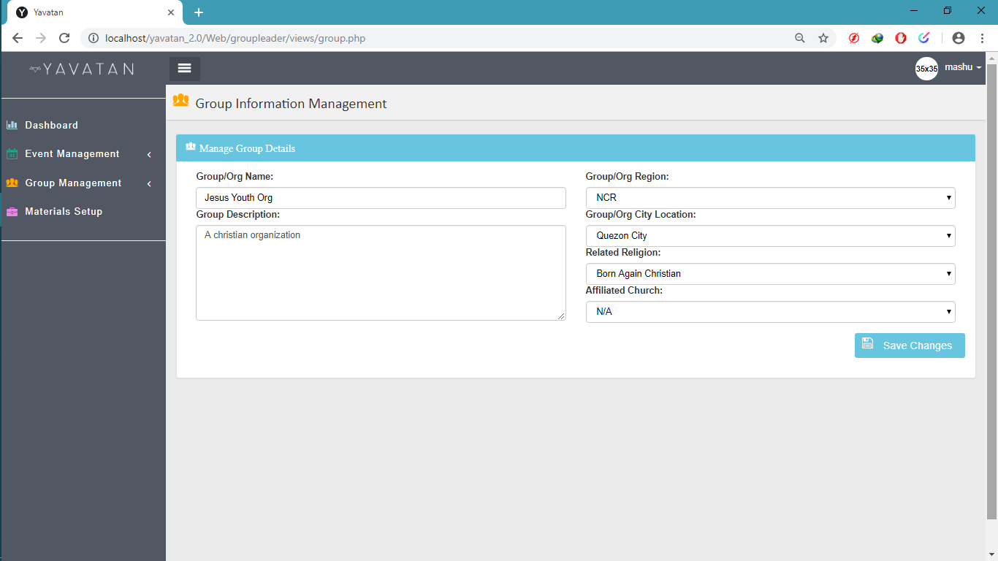

The Figure above is used to manage the group details of the group leader.

**Figure 32. Group-Member Management (Group-Leader’s Page)**

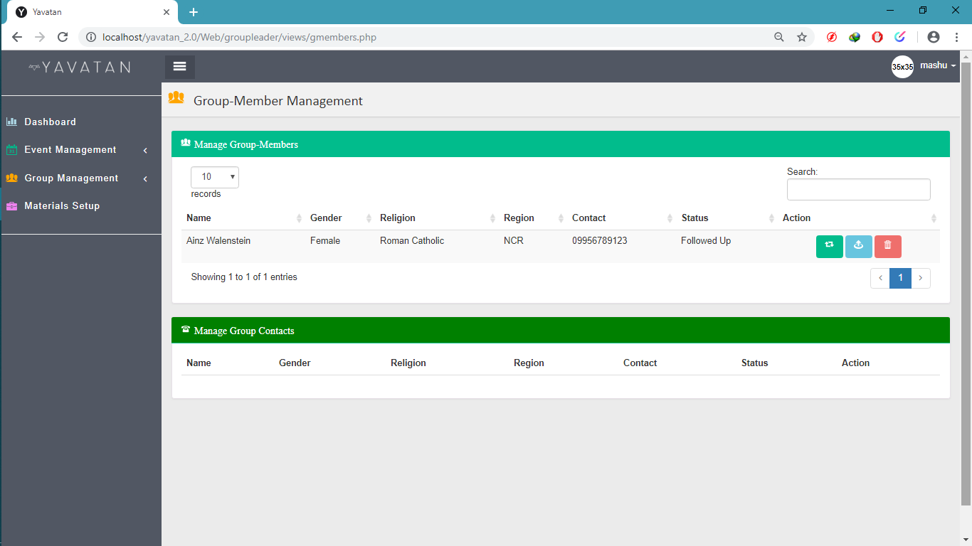

The Figure above is used to manage all the listed members of the group.

**Figure 33. Materials Management (Group-Leader’s Page)**

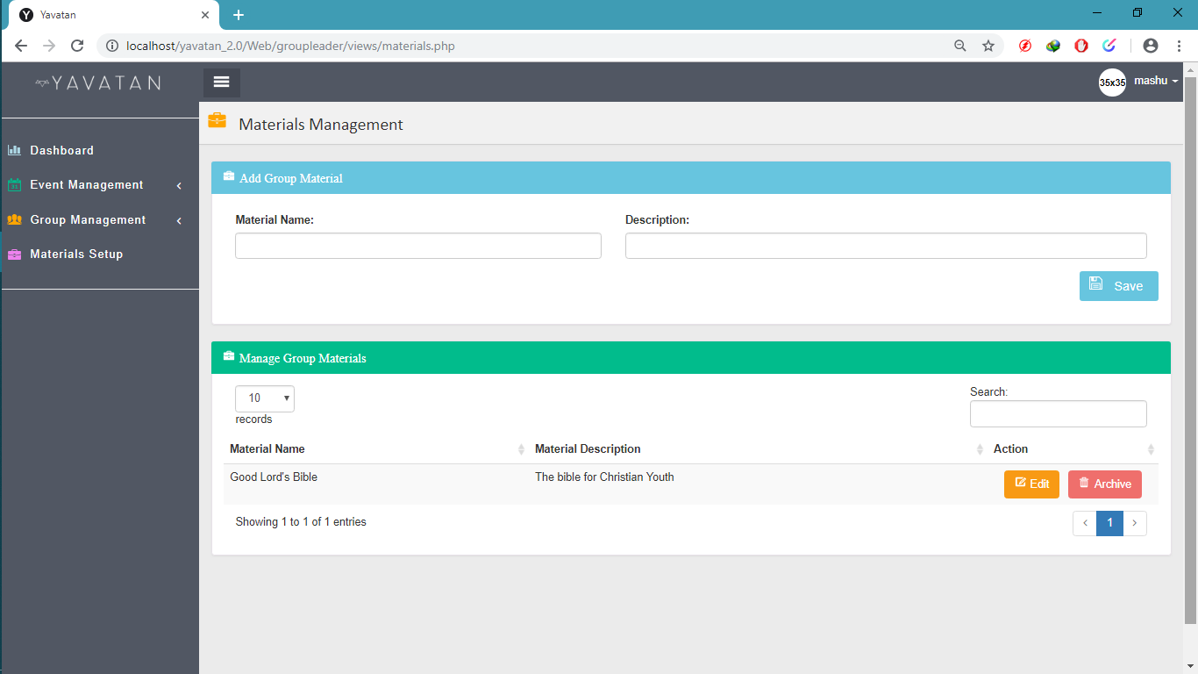

The Figure above is used where the group leader can manage all the materials used in the events or group.

**Figure 34. User Role Management (Admin’s Page)**

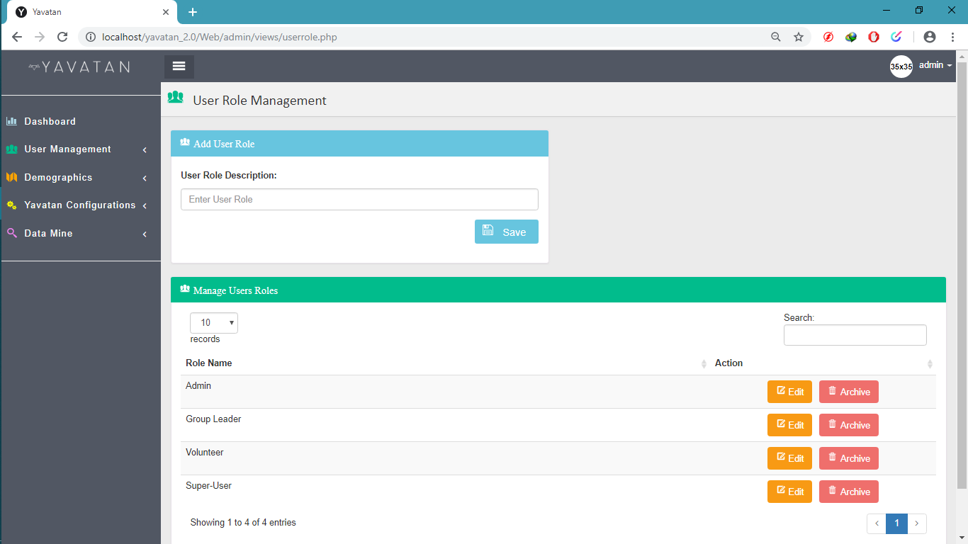

The figure above is used to add, update and archive user roles.

**Figure 35. Account Management (Admin’s Page)**

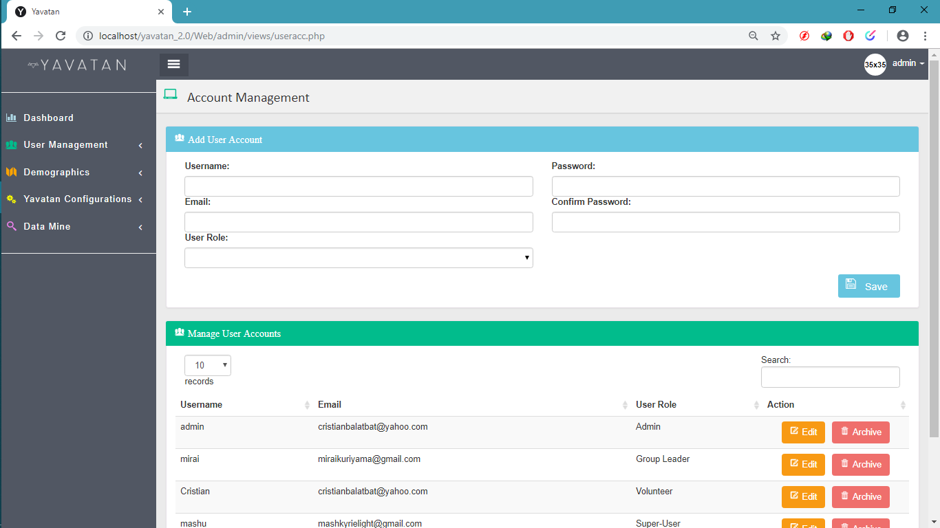

The figure above used to manage accounts in the system.

**Figure 36. Group/Organization Management (Admin’s Page)**

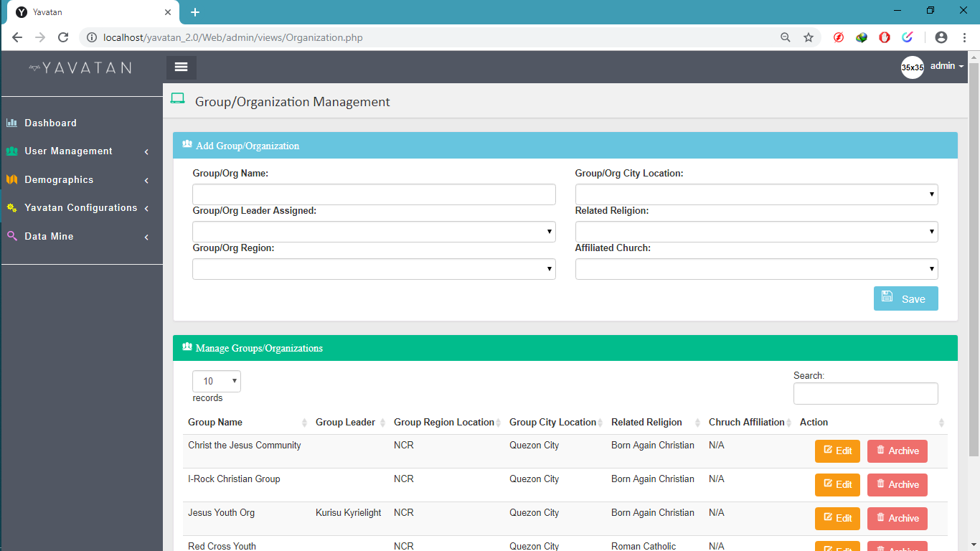

The figure above shows all the group/organization created, you can view their details, add, edit and archive

**Figure 37. Group Leader Management (Admin’s Page)**

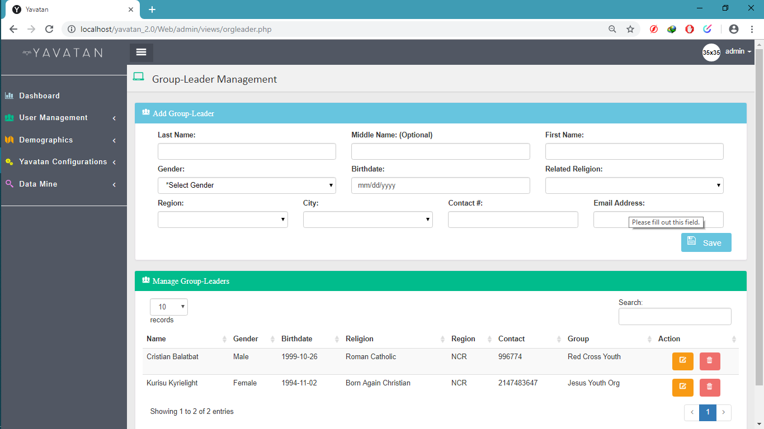

The figure above shows all the list of group leaders, you can add, edit and delete.

**Figure 38. Regions Management (Admin’s Page)**

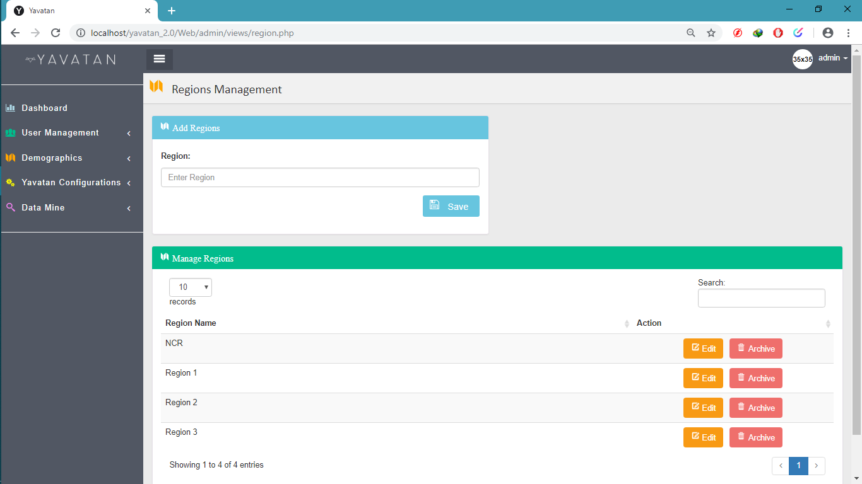

The figure above is used to manage regions, regions used to select where the volunteer address located.

**Figure 39. City Management (Admin’s Page)**

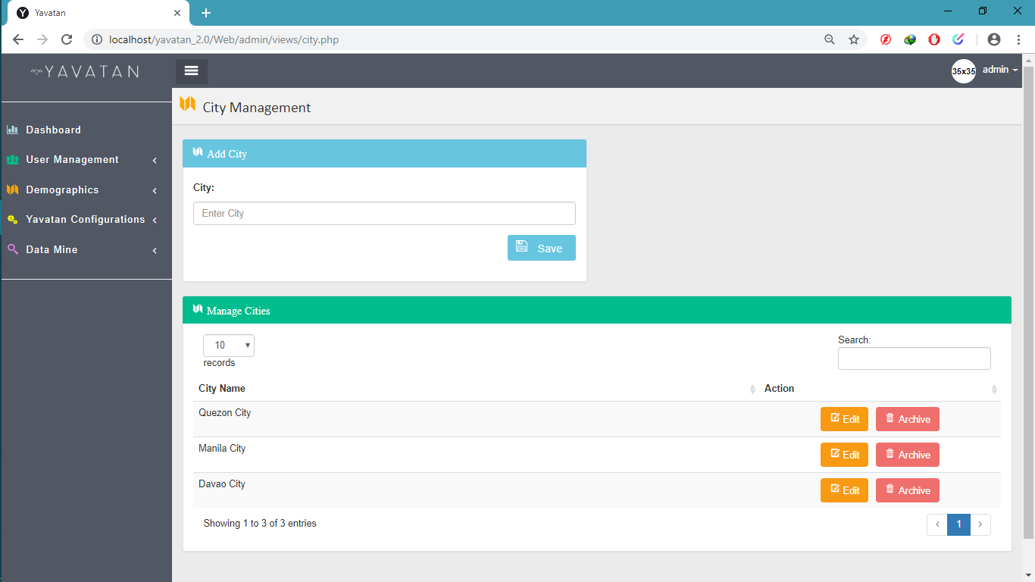

The figure above is used for the administrator where he/she can manage cities.

**Figure 40.** **Religion Management (Admin’s Page)**

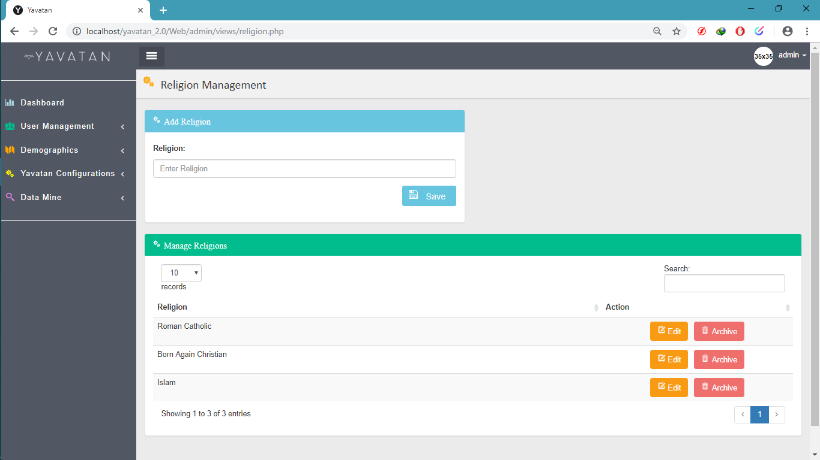

The figure above is used to manage religion that will used by the system.

**Figure 41.** **Church Management (Admin’s Page)**

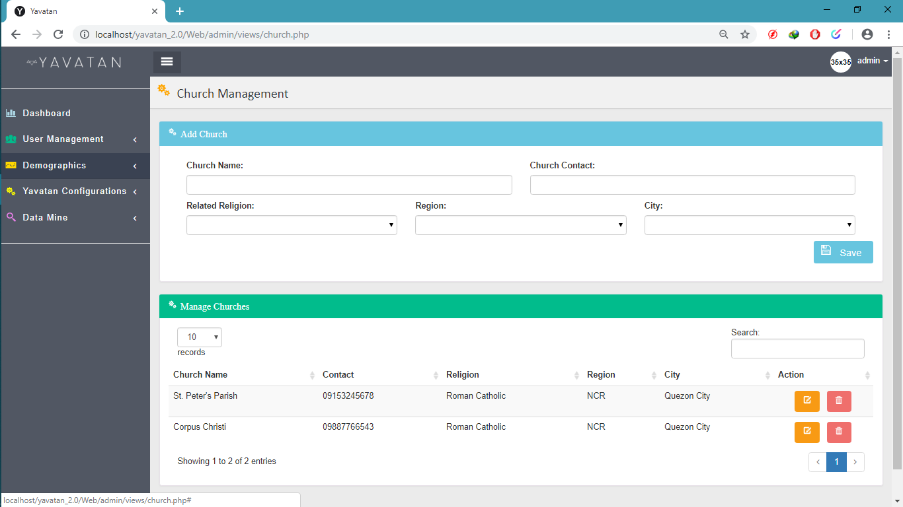

The figure above is used by the administrator to view, add, edit and archive churches.

**Figure 42. Event Type Management (Admin’s Page)**

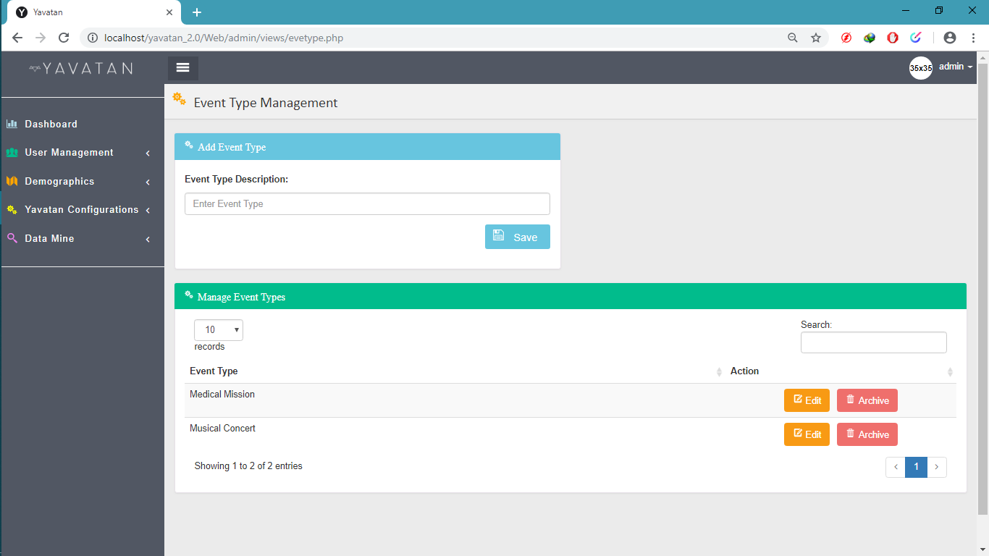

The Figured above is used to add, edit and archive event types.

**Figure 43. Event Audience Management (Admin’s Page)**

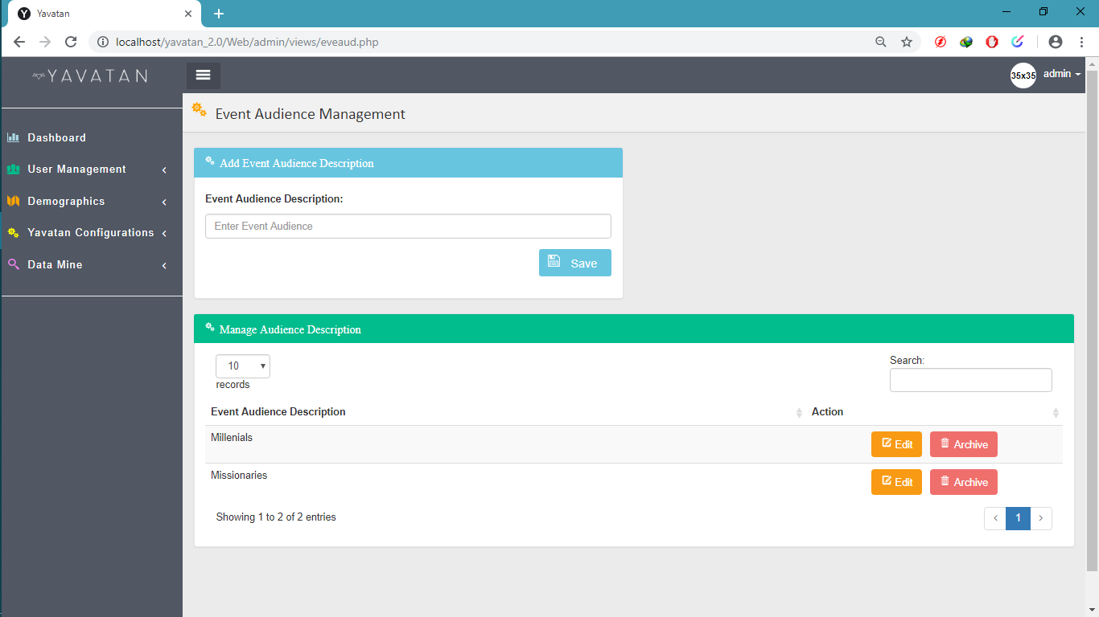

The Figure above is used to view, add edit and archive events audience.

1. **Project Outcome**

**5.1 Conclusion**

Yavatan Digital Mission Christian Strategies System is an Event Management system application specifically made for religious youth groups. The system offers features that will greatly help the group leaders of a particular group to create and manage their events and group members. The greatest feature of the system, which is the predictive analysis, provides a prescriptive assistance for the group leaders in terms of creating events, as they can be given an analysis and to use it to create more effective and good events.

The Main 7 Core Functionalities of the system are as follows: Registration, Event Management, User Account Management, Group Management, Attendance Management, Data Mining, and the Predictive Analysis. These core functionalities are the main foundation of the system. The system is only built as a web application. User accesses to the said functionalities will depend on the 2 main users – the group leaders and the volunteers.

This project is planned and executed only in 2 sprints (4 weeks), from November 1, 2018 up to November 28, 2018. Working hours in weekends are also included. The development of the said system is divided into modules, and distributed into different sprints, categorized by priorities, and by that, the short-term and long-term development tasks are determined. The project team ensures that the deliverable will be a working system in terms of core functionality, but the team still considers further improvement that can be applied later on in the system.

**5.2 Recommendation**

The Yavatan project team recommends the following:

1. The first use of the system must be supervised by the project team to have its first-time users to be well-guided and oriented.
2. The documentation of the system must be reviewed by the quality assurance team and its users to be well-guided in using the system.
3. The Yavatan can be recommended by its users to other colleagues or other youth groups, if the initial system testers, or the beta-testers is in favored of using the system as an event and group management system.
4. If there are revisions, the quality assurance group must consult the project development team if there are necessary changes to be made.
5. The team recommends suggestions and insights from its testers and users to use it as a basis for future improvement of the system, both to its business process and technology application.